Supplementary Materials for Charpentier et al, “Genetic structure in a dynamic baboon hybrid zone corroborates behavioral observations in a hybrid population”

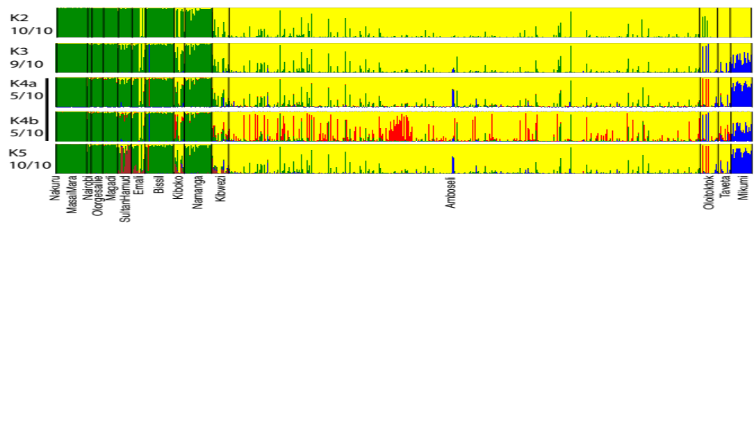
Figure S1. Genetic structure inferred by TESS for K_{max} =2 to 5. Each barplot includes a vertical line for each individual in the analysis. Ancestry fractions for each individual are represented by dividing this line into K colored segments that reflect the membership proportion in each cluster. Vertical black lines separate individuals from different populations. We obtained two modal solutions for K = 4, and these two sets of results are represented as “K4a” and “K4b.” We detected relatively little additional structure within yellow baboons or anubis baboons, with the exception of a cluster that defines the Mikumi yellow baboon population at K = 3 and above. This distinction likely reflects morphotype classifications within yellow baboons: most of the yellow baboons in our sample represent the “ibean” morphotype, but Mikumi individuals represent the “typical” yellow baboon morphotype (see Jolly 1993 for more details).
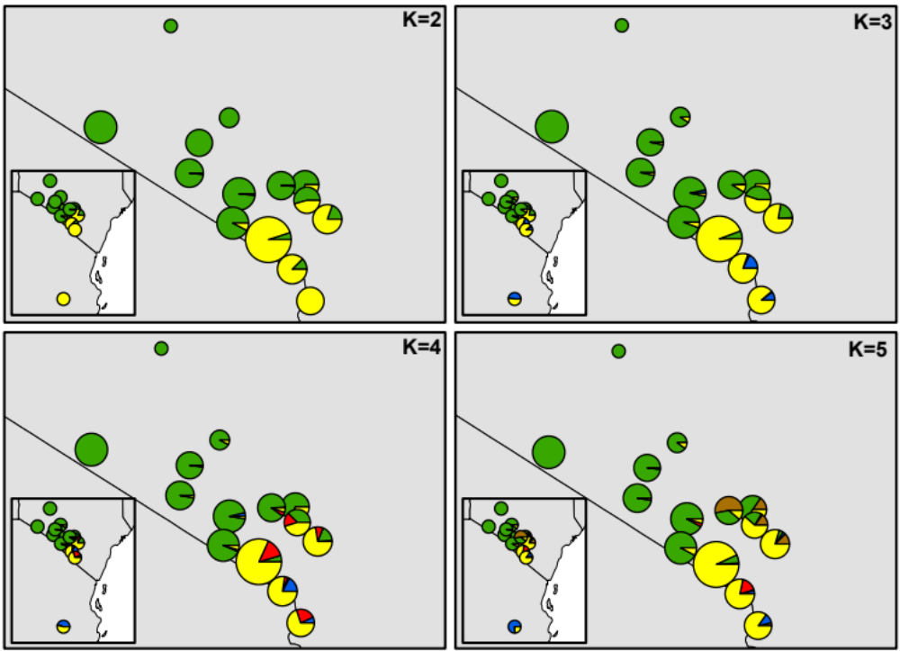

Figure S2. Ancestry fractions for each sampled population (inset includes Mikumi). Each color represents a different cluster in K; for K = 2, green reflects anubis baboon ancestry and yellow reflects yellow baboon ancestry. Sizes of each circle are proportional to the number of samples obtained from that population.

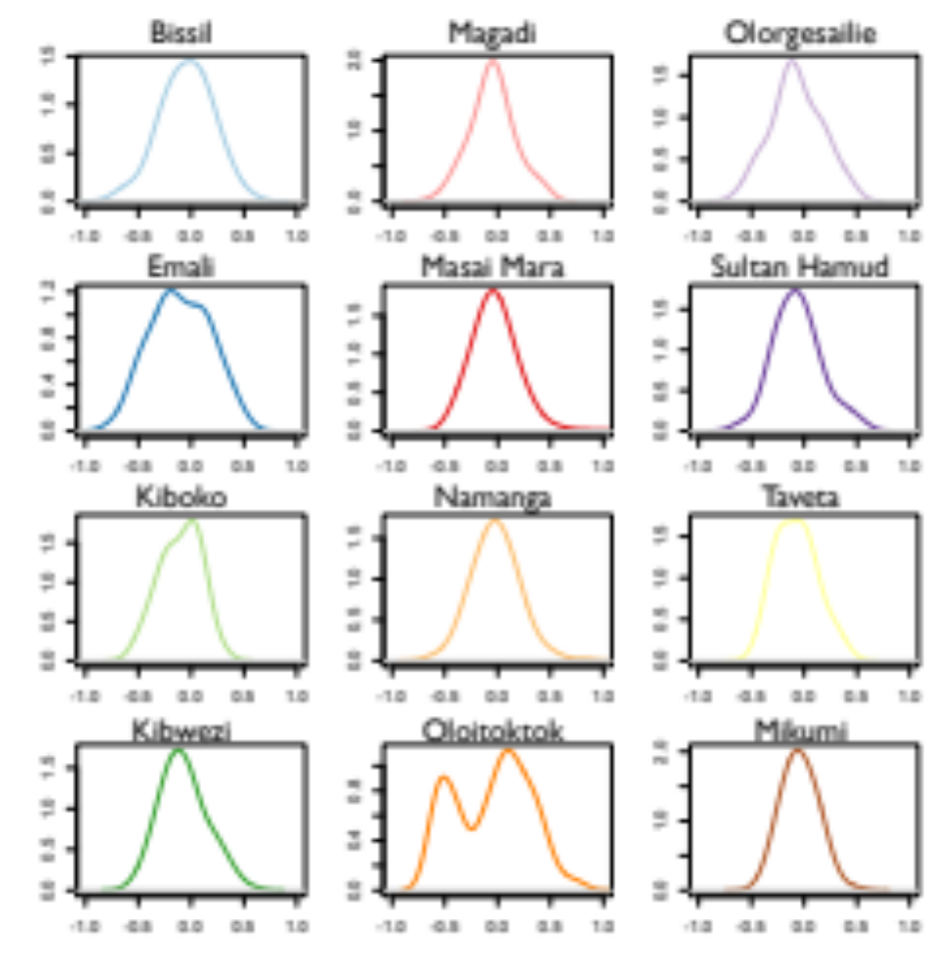
Figure S3. Distribution of pairwise relatedness values for 11 populations. Relatedness values for all populations sampled de novo (including newly sampled individuals from Masai Mara) are unimodal, with the exception of the bimodal distribution observed for Oloitoktok. No distribution is shown for Nakuru (n = 1) and Nairobi (n = 6).
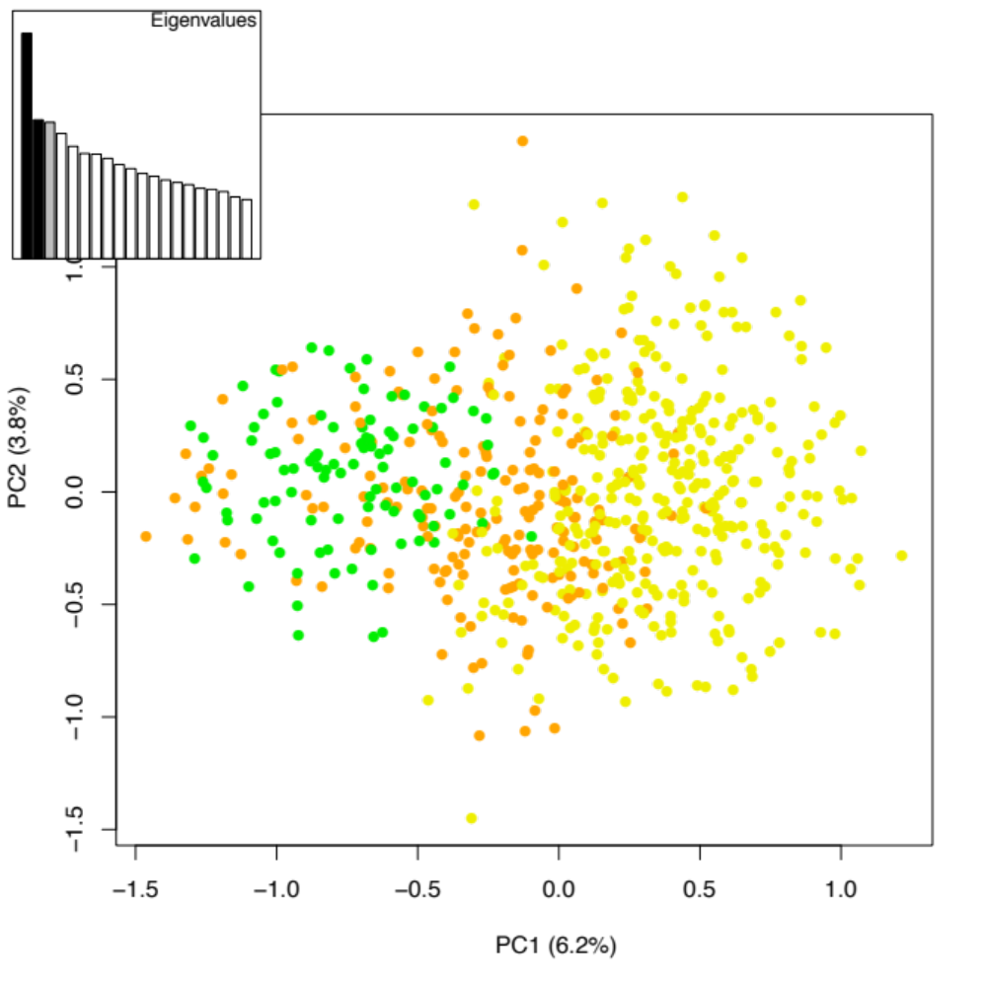
Figure S4. Principal component plot of genetic variation in the data set. Anubis and yellow baboons are largely separated by the first principal component of variation (x-axis) in the microsatellite markers genotyped for this study. Unadmixed yellow baboons (following TESS assignment and the criterion that q > 0.98) are shown as yellow dots; unadmixed anubis baboons are shown in green dots; likely hybrids are shown as brown dots. The second principal component is shown on the y-axis, and the decay in the magnitude of successive eigenvalues is depicted in the inset.
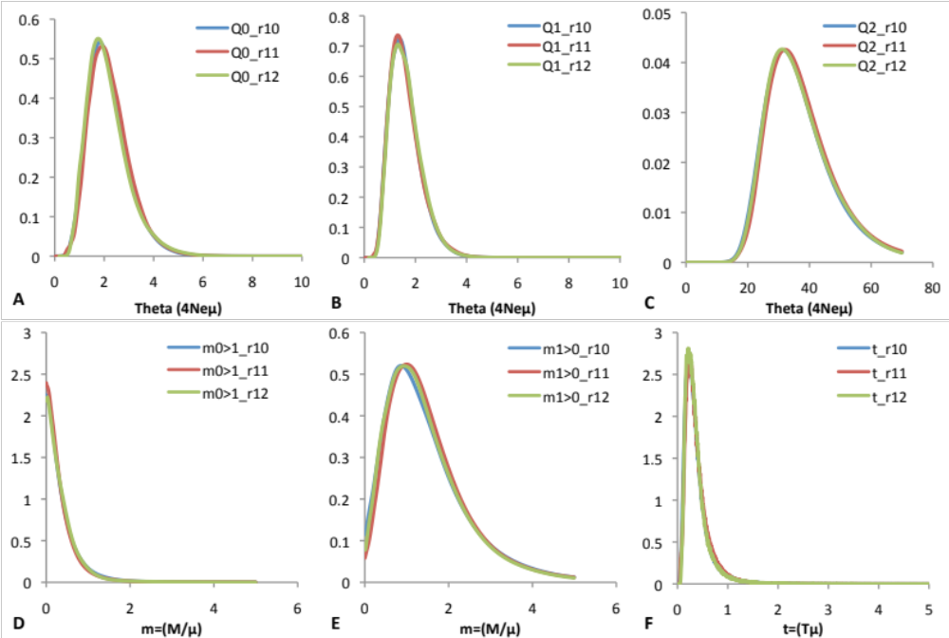

Figure S5. Marginal posterior distributions for each of 3 IMa2 runs for the Masai Mara-Mikumi comparison. A) scaled effective population size for anubis; B) scaled effective population size for yellow; C) scaled ancestral effective population size; D) migration rate from yellow into anubis; E) migration rate from anubis into yellow; F) divergence time.
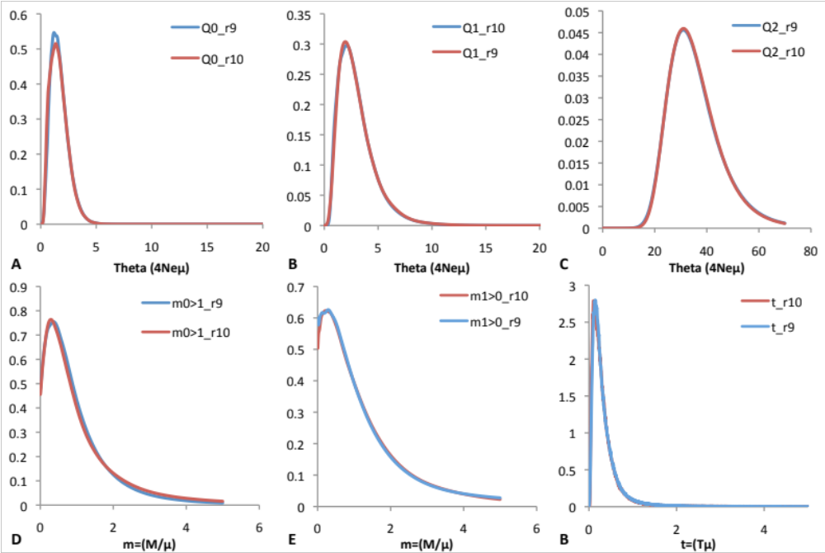

Figure S6. Marginal posterior distributions for each of 2 IMa2 runs for the Masai Mara-Taveta comparison. A) scaled effective population size for anubis; B) scaled effective population size for yellow; C) scaled ancestral effective population size; D) migration rate from yellow into anubis; E) migration rate from anubis into yellow; F) divergence time.

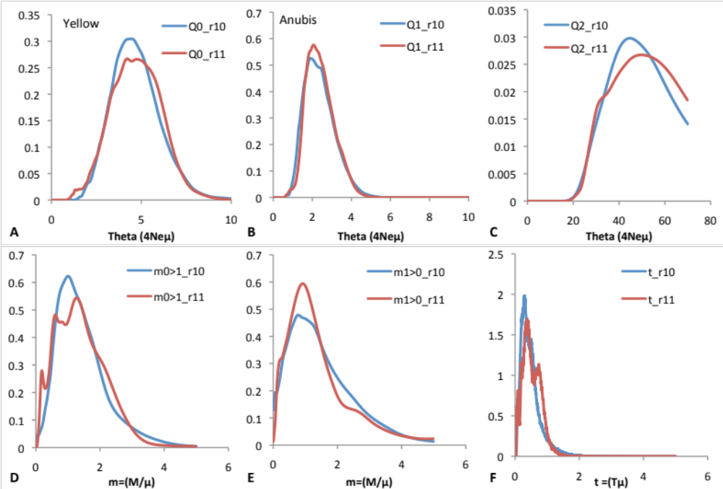

Figure S7. Marginal posterior distributions for each of 2 IMa2 runs for the Namanga/Bissil/Sultan Hamud-Amboseli/Kibwezi/Oloitoktok comparison. A) scaled effective population size for yellow; B) scaled effective population size for anubis; C) scaled ancestral effective population size; D) migration rate from anubis into yellow; E) migration rate from yellow into anubis; F) divergence time.

Table S1. Sample size and location by population.
Population (location) | Main species observed¹ | Latitude | Longitude | N
Masai Mara | Anubis | -1° 26' 27.6" | 35° 12' 47.2032" | 28
Nakuru | Anubis | 0° 21' 53.298" | 36° 3' 35.193" | 1
Magadi | Anubis | -1° 55' 44.6988" | 36° 17' 13.4988" | 14
Olorgesailie | Anubis | -1° 36' 27.6012" | 36° 24' 16.1964" | 11
Nairobi | Anubis | -1° 20' 21.0012" | 36° 46' 4.3932" | 4
Namanga | Anubis | -2° 27' 33.699" | 36° 48' 43.902" | 26
Bissil | Anubis | -2° 8' 58.797" | 36° 53' 9.1926" | 27
Amboseli | Yellow | -2° 38' 6.0288" | 37° 14' 32.316" | 446
Sultan Hamud | Anubis | -2° 3' 37.9008" | 37° 23' 41.9058" | 13
Emali | - | -2° 3' 0.6012" | 37° 36' 22.5036" | 13
Kiboko | - | -2° 13' 0.4974" | 37° 42' 26.3016" | 10
Kibwezi | Yellow | -2° 25' 4.9974" | 37° 57' 12.801" | 16
Oloitoktok | Yellow | -2° 56' 55.7988" | 37° 31' 46.4988" | 17
Taveta | Yellow | -3° 17' 10.2984" | 37° 45' 5.0004" | 12
Mikumi | Yellow | -7° 24' 8.6616" | 36° 59' 30.3786" | 20
¹This column reflects observational notes taken by the authors during sampling.

Table S2: Scoring rules for microsatellite genotypes using the multitube approach¹.
Number of PCR reactions | Heterozygous genotypes | Homozygous genotypes
4 | At least 2 AB; 1AB + AA + BB | 4 AA
8 | At least 3 AB; 2 AB + AA + BB; 3 AB + AC; 4AB + CC (or CD) | 6 AA
¹Initially, four replicate positive PCRs were carried out for each individual at each locus. An individual was scored as homozygous only if the four PCRs detected the same allele all four times. An individual was scored as heterozygous if at least two PCR reactions yielded a heterozygous genotype, or if one PCR reaction yielded a heterozygous genotype and both alternative homozygous genotypes were observed at least once. Any other result led us to perform four new genotyping reactions for that locus.

Table S3. Proportion of allelic dropout and contamination per locus analyzed¹.

Locus | % allelic dropout | % foreign allele (contamination)
AGAT0006 | 4.39% | 0.05%
D14S306 | 7.02% | 0%
D3S1768 | 8.07% | 0.12%
D1S1656 | 6.05% | 0.76%
D4S243 | 7.93% | 0.68%
D6S501 | 10.53% | 0.56%
D13S159B | 8.45% | 0.80%
D7S503 | 5.68% | 0.41%
D10S611 | 9.23% | 0.40%
D11S2002 | 11.83% | 0.09%
D18S851 | 13.59% | 0.35%
D8S1106 | 6.82% | 1.60%
¹These percentages are calculated from all genotypes scored according to the rules detailed in Table S2.

Table S4. Parameters, settings, run times, and number of genealogies saved and used for parameter estimations in IMa2.
 | Data sets |  | Priors and run settings |  |  |  |  |  |  | Run-time, genealogies saved and used
 | Pop 1 | Pop 2 | è | m | t | #MCMC | heating | ha | hb | b | l | G | T | D | Used
run 10 | Masai Mara | Mikumi | 70 | 5 | 5 | 100 | hfg | 0.90 | 0.40 | 767 765 | 8 494 487 | 84 945 | 486 | 20 | V
run 11 | Masai Mara | Mikumi | 70 | 5 | 5 | 100 | hfg | 0.98 | 0.50 | 813 811 | 6 334 329 | 63 344 | 505 | 21 | V
run 12 | Masai Mara | Mikumi | 70 | 5 | 5 | 100 | hfg | 0.99 | 0.40 | 696 694 | 5 448 444 | 54 485 | 504 | 21 | V
 |  |  |  |  |  |  |  |  |  |  |  | 202 774 |  |  | 100 000
run 9 | Masai Mara | Taveta | 70 | 5 | 5 | 100 | hfg | 0.99 | 0.40 | 731 729 | 8 594 587 | 85 946 | 484 | 20 | V
run 10 | Masai Mara | Taveta | 70 | 5 | 5 | 100 | hfg | 0.98 | 0.50 | 1 081 078 | 8 594 587 | 85 946 | 502 | 21 | V
 |  |  |  |  |  |  |  |  |  |  |  | 171 892 |  |  | 100 000
run 10 | AmbKibwOloi | NaBisSult | 70 | 5 | 5 | 100 | hfg | 0.95 | 0.40 | 446 444 | 3 122 120 | 31 222 | 505 | 21 | V
run 11 | AmbKibwOloi | NaBisSult | 70 | 5 | 5 | 100 | hfg | 0.98 | 0.50 | 386 384 | 2 687 686 | 26 877 | 506 | 21 | V
 |  |  |  |  |  |  |  |  |  |  |  | 58 099 |  |  | 50 000
θ: population genetic diversity (4Neµ)
m: migration rate (M/µ)
t: splitting time (Tµ)
heating (hfg): geometric heating scheme
ha: first parameter of the hfg
hb: second parameter of the hfg
b: burn-in length (MCMC steps)
l: length of the run (MCMC steps)
G: # genealogies saved
T: run duration (in hours)
Used: runs and number of genealogies used for the parameter estimations

Table S5. Pairwise F_{ST} values between populations (below the diagonal) and p-value for F_{ST} estimates (above the diagonal).
 | Amboseli | Bissil | Emali | Kiboko | Kibwezi | Magadi | Mikumi | Masai Mara | Nairobi | Namanga | Oloitoktok | Olorgesailie | Sultan Hamud | Taveta
Amboseli | — | 0.0006 | 0.0006 | 0.0011 | 0.0006 | 0.0006 | 0.0006 | 0.0006 | NA | 0.0006 | 0.0006 | 0.0006 | 0.0006 | 0.0006
Bissil | 0.093 | — | 0.0456 | 0.0484 | 0.0022 | 0.0017 | 0.0006 | 0.0011 | NA | 0.0011 | 0.0055 | 0.0429 | 0.0412 | 0.0088
Emali | 0.069 | 0.035 | — | 0.1731 | 0.0269 | 0.0242 | 0.0066 | 0.0242 | NA | 0.0385 | 0.0286 | 0.1687 | 0.1610 | 0.0780
Kiboko | 0.036 | 0.061 | 0.015 | — | 0.0286 | 0.0736 | 0.0066 | 0.0220 | NA | 0.0407 | 0.0725 | 0.1665 | 0.1692 | 0.0615
Kibwezi | 0.049 | 0.099 | 0.050 | 0.016 | — | 0.0006 | 0.0006 | 0.0011 | NA | 0.0011 | 0.0050 | 0.0291 | 0.0324 | 0.0011
Magadi | 0.079 | 0.053 | 0.055 | 0.042 | 0.069 | — | 0.0006 | 0.0006 | NA | 0.0011 | 0.0006 | 0.0742 | 0.0451 | 0.0017
Mikumi | 0.062 | 0.136 | 0.089 | 0.066 | 0.071 | 0.119 | — | 0.0006 | NA | 0.0011 | 0.0006 | 0.0066 | 0.0060 | 0.0006
Masai Mara | 0.082 | 0.051 | 0.061 | 0.042 | 0.071 | 0.056 | 0.118 | — | NA | 0.0011 | 0.0006 | 0.0236 | 0.0264 | 0.0039
Nairobi | 0.085 | 0.073 | 0.042 | 0.048 | 0.078 | 0.081 | 0.109 | 0.072 | — | NA | NA | NA | NA | NA
Namanga | 0.113 | 0.033 | 0.061 | 0.065 | 0.101 | 0.071 | 0.158 | 0.064 | 0.100 | — | 0.0022 | 0.0357 | 0.0363 | 0.0039
Oloitoktok | 0.035 | 0.104 | 0.090 | 0.064 | 0.064 | 0.094 | 0.080 | 0.095 | 0.094 | 0.127 | — | 0.03352 | 0.03846 | 0.00495
Olorgesailie | 0.086 | 0.046 | 0.063 | 0.038 | 0.102 | 0.053 | 0.129 | 0.050 | 0.019 | 0.082 | 0.088 | — | 0.16044 | 0.06978
Sultan Hamud | 0.102 | 0.074 | 0.050 | 0.058 | 0.110 | 0.105 | 0.134 | 0.101 | 0.055 | 0.090 | 0.137 | 0.070 | — | 0.06484
Taveta | 0.041 | 0.122 | 0.079 | 0.040 | 0.051 | 0.093 | 0.069 | 0.093 | 0.081 | 0.125 | 0.075 | 0.112 | 0.110 | —

Table S6. Descriptive statistics by population1
 | n | #A | Ar | H_{e} | F_{IS}
Amboseli | 446 | 9.3 | 3.0 | 0.80 | -0.024²
Bissil | 27 | 7.3 | 2.9 | 0.77 | 0.005
Emali | 13 | 6.3 | 3.0 | 0.81 | 0.026
Kiboko | 10 | 6.2 | 3.2 | 0.83 | -0.050
Kibwezi | 16 | 6.3 | 2.9 | 0.78 | 0.001
Magadi | 14 | 7.0 | 3.0 | 0.79 | -0.052
Mikumi | 20 | 6.8 | 2.9 | 0.76 | 0.001
Masai Mara | 28 | 6.8 | 2.9 | 0.79 | -0.013
Nairobi | 4 | 4.2 | 3.1 | 0.81 | -0.009
Namanga | 26 | 6.9 | 2.8 | 0.73 | -0.016
Oloitoktok | 17 | 7.7 | 3.0 | 0.79 | -0.008
Olorgesailie | 11 | 5.8 | 2.9 | 0.80 | 0.083
Sultan Hamud | 13 | 5.8 | 2.9 | 0.77 | 0.012
Taveta | 12 | 6.5 | 3.1 | 0.81 | -0.071
¹Abbreviations are as follows: #A: number of alleles; Ar: allelic richness calculated using ADZE; H_{e}: expected heterozygosity (or Nei’s genetic diversity); F_{IS}: inbreeding coefficient.
²Amboseli exhibits an excess of heterozygotes, p < 0.001 via a permutation test.

Table S7: Point estimates and 95% HPD intervals of parameter estimates under the IM model, converted to demographic units¹.
 | Far from the hybrid zone¹ |  |  | Intermediate distance from the hybrid zone² |  |  | Bordering the hybrid zone³
 | Mode | HPD95Low | HPD95High | Mode | HPD95Low | HPD95High | Mode | HPD95Low | HPD95High
T (years) | 3 880 | 920 | 13 800 | 2 120 | 280 | 15 800 | 5 320 | 680 | 16 680
Ne_{Anubis} | 928 | 368 | 1 978 | 648 | 193 | 1 663 | 998 | 473 | 1 978
Ne_{Yellow} | 683 | 263 | 1 453 | 998 | 263 | 3 238 | 2 118 | 1 033 | 3 728
Ne_{Ancestral} | 15 768 | 9 573 | 29 348 | 15 523 | 9 258 | 27 843 | 23 223 | 14 438 | 34 983
2NM into Anubis | 0.04 | 0 | 0.87 | 0.48 | 0 | 1.40 | 1.37 | 0.07 | 2.84
2NM into Yellow | 0.94 | 0.12 | 1.84 | 0.98 | 0 | 2.99 | 2.94 | 0.45 | 5.44
¹ Values are provided for the three pairs of populations from each baboon species and converted to demographic units using a mutation rate of 5 x 10⁻⁴ and a generation time of 8 years.
² Results from the comparison of Masai Mara anubis baboons and Mikumi yellow baboons, the two populations furthest from one another.
³ Results from the comparison of Masai Mara anubis baboons and Taveta yellow baboons.
⁴ Results from the comparison of Namanga, Bissil, and Sultan Hamud anubis baboons and Amboseli, Kibwezi, and Oloitoktok yellow baboons.

