Better baboon breakups: Collective decision theory of complex social network fissions

Brian A. Lerch^{1,2,*}, Karen C. Abbott², Elizabeth A. Archie³, and Susan C. Alberts^{4,5}

¹ Department of Biology, University of North Carolina at Chapel Hill
² Department of Biology, Case Western Reserve University
³ Department of Biological Sciences, University of Notre Dame
⁴ Department of Evolutionary Anthropology, Duke University
⁵ Department of Biology, Duke University

*blerch@live.unc.edu

Abstract

Many social groups are made up of complex social networks in which each individual associates with a distinct subset of its groupmates. If social groups become larger over time, competition often leads to a permanent group fission. During such fissions, complex social networks present a collective decision problem and a multidimensional optimization problem: it is advantageous for each individual to remain with their closest allies after a fission, but impossible for every individual to do so. Here, we develop computational algorithms designed to simulate group fissions in a network theoretic framework. We focus on three fission algorithms (‘democracy,’ ‘community,’ and ‘despotism’) that fall on a spectrum from a democratic to a dictatorial collective decision. We parameterize our social networks with data from wild baboons (Papio cynocephalus) and compare our simulated fissions with actual baboon fission events. We find that the democracy and community algorithms (egalitarian decisions where each individual influences the outcome) better maintain social networks during simulated fissions than despotic decisions (driven primarily by a single individual). We also find that egalitarian decisions are better at predicting the observed individual-level outcomes of observed fissions, although the observed fissions often disturbed their social networks more than the simulated egalitarian fissions.

Keywords: Consensus decision making; Collective action; Democratic decisions; Despotism; Group fissions; Social bonds

Introduction

Links between social bonds and fitness in multiple species suggest that the maintenance of bonds is an important target of selection¹⁻⁴. However, even in species that build and maintain strong bonds, social groups may fission, leading to the dissolution of social bonds. While fissions may benefit individuals, for instance by reducing intragroup competition⁵⁻¹¹, increasing resource availability^{12,13}, improving breeding opportunities¹⁴⁻¹⁶, or maintaining high relatedness within social units¹⁷, it is unlikely that every individual can maintain its preferred set of social bonds during the fission. What strategies can individuals take to achieve the complicated collective decision of splitting up a social network? How can individuals best maintain social ties during group fissions, even when networks are complex?
Despite the complexity of fission decisions at the individual level, common patterns may emerge at the level of the social network during group fissions. Network theoretic approaches are vital to studying animal sociality¹⁸, including group fissions. In particular, network-theoretic models have studied how nutritional needs interact with sociality to favor fission-fusion societies (in which frequent temporary fissions and fusions occur) or permanent group fissions¹³, and empirical studies have shown that resource availability shapes fission-fusion dynamics¹². Network approaches have been extended to understand how grooming relationships in primates influence social group cohesion and whether a permanent fission will occur^{19,20}, often focusing on the immediate benefits of fissions.
A different, albeit related, question is how different decision processes – for instance processes driven by one individual versus many – influence the fission and its outcome. Collective decision theory, which has studied how democratic versus despotic decisions affect animal movement, provides a means to understand these decision processes²¹⁻²⁷. Collective decision theory has also addressed fission processes in animal social groups^{13,19}, focusing on fission-fusion societies²⁸⁻³⁰. Permanent fissions are different from temporary fissions for two reasons. First, because group fissions in fission-fusion societies are transient, fission decisions do not permanently separate individuals from their allies, making them lower-stakes than permanent fissions. Second, temporary fission events represent highly flexible and dynamic short-term responses to ephemeral changes in the spatial distribution of resources; in contrast, permanent fissions represent fixed, long-term changes that presumably require different information and have different implications for the social group^{13,19}. Thus, existing theory on fission-fusion dynamics cannot readily inform an understanding of permanent social group fissions.
Group-living primates provide excellent case studies of permanent group fissions from a network perspective, as social networks influence both group fissions¹⁹ and collective decisions³¹ in some primates. Most primates live in stable social groups rather than fission-fusion societies³²⁻³⁴, so the decision of which post-fission group to join during a permanent social group fission influences an individual for the remainder of its life. Further, primate group fissions appear not to follow simple, universal rules, and multiple processes might determine post-fission group membership. For instance, permanent group fissions in matrilineal societies (e.g., baboons and macaques) are commonly characterized by an attempt to remain with matrilineal kin^{6,35-38}. However, this general rule is not universally followed^{34,35,38,39}. In one study of baboons, individuals appeared to make decisions that improved their social dominance rank following the fission⁴⁰. In contrast, in a study of four different fissions in one population of savannah baboons, Van Horn and colleagues³⁴ concluded that female baboons follow a flexible decision-making process that maximizes their ability to maintain close social ties with close kin. They found that female baboons remained with close maternal kin if those were abundant, but females without close maternal kin remained with close paternal kin or non-kin to whom they bonded. Thus, even in the same population or social group, individuals vary in which types of bonds are maintained or broken during permanent fissions, indicating that a global, network-centric view may provide insights that individual-level analyses cannot.
Here, we combine social network analysis and collective decision theory to understand how different collective decision processes produce permanent social group fissions. We do not consider why fissions occur, which has been addressed extensively^{5,6,9,12-14,16,17,28,40}. Instead, we focus on how fissions occur¹⁹ by developing computational algorithms that simulate group fissions, using three different decision processes that range from democratic and community-based decision processes (i.e., ‘egalitarian’ processes in which multiple individuals contribute to the outcome) to a despotic process (in which a single individual dominates the process). We make comparisons against a random algorithm and an ‘efficient non-behavioral’ algorithm that set benchmark expectations for disruptive and non-disruptive fissions, respectively. We parameterize social networks with empirical data from the Amboseli baboon population⁴¹. We ask three questions about simulated and observed fission outcomes, two that concern network-level metrics (percentage of bonds broken, weight of bonds broken, etc.), and one that concerns individual-level outcomes: (1) How well do the observed fissions maintain social network structure by minimizing the number and strength of bonds broken (i.e., how ‘efficient’ are observed fissions)? (2) How well do the simulated fissions, created with strategies from our collective decision algorithms, maintain social network structure by minimizing the number and strength of bonds broken (i.e., how ‘efficient’ is each algorithm)? (3) How well does each collective decision algorithm predict which specific bonds were broken by the baboons during the observed fissions (i.e., how well do the algorithms match observed data)? Answers to the first two questions characterize how disruptive different types of fissions are to social networks. Importantly, however, an algorithm that disrupts the network to a similar degree as an observed baboon group fission may not disrupt the network in similar ways. Therefore, while the first two questions contextualize the efficiency of real fissions, the third question is key for evaluating which algorithm best matches the outcomes of the observed fissions.

Methods

Case Study: Amboseli Baboons

Since 1971, the Amboseli Baboon Research Project has recorded data on group membership and social relationships for multiple social groups⁴¹ that have undergone seven natural fission events. The population consists primarily of yellow baboons (P. cynocephalus) with some admixture from anubis baboons (P. anubis)⁴²⁻⁴⁴. Group membership is assessed during near-daily censuses of animals in study groups, with animals recognized on sight⁴⁵⁻⁴⁸. Social dominance ranks are assigned monthly and separately for each sex based on the outcomes of dyadic agonisms between all pairs of individuals in the same social group, with highest ranking individuals having rank 1^{45,49}. Specifically, we create an N x N matrix of individuals of each sex; each cell in the matrix contains a number that represents the number of wins that month by the individual represented in that row over the individual represented in that column. Individuals are ordered so that entries below the diagonal are minimized. This order is the ordinal ranking of individuals⁴⁹.
Grooming is the most significant investment that adult baboons make in social affiliations and thus a reliable proxy for social relationships in dyads (hereafter, social bond strength; discussed in⁵⁰⁻⁵²). Grooming was recorded whenever one animal picked through the fur of another animal and appeared to remove ectoparasites and debris. Grooming was considered to have ceased if the hands of the groomer left the body of the groomed animal for more than 5 seconds⁴⁵. Grooming data were collected using a sampling protocol designed to avoid biases from uneven sampling. Observers attempted to record all occurrences of grooming in their line of sight while simultaneously carrying out random-order, 10-minute focal animal samples on adult females and juveniles. This sampling procedure ensured that observers continually moved to new locations within the group and observed all adult females and juveniles on a regular rotating basis⁵².
To parameterize social networks for the seven baboon groups that fissioned, we used grooming data from two years prior to the start of each fission event: the inherent sparsity of the grooming data mean that reliable social networks cannot be obtained with shorter stretches of time. The strongest bonds (those most likely to drive fission decisions) are also the most stable⁵¹ and thus unlikely to change dramatically over the two-year period. We tallied the number of grooming events between all pairs of adults in the group (age 5 and older) and divided by the largest number of grooming events for a single dyad within the group to normalize values between 0 and 1. We retained only bonds between pairs that had groomed at or above the average level for a given group (typically the strongest 25-30% of bonds; in supplemental analyses, we also considered ‘unfiltered’ networks with all bonds retained; figures S1-S3). We assigned edge weights on the network based on bond strengths. We removed from the network individuals that had no bonds of above-average strength (46 of 327, ~14% of individuals), leaving connected networks. We removed bonds that were below-average in strength as they are less stable⁵¹, primarily adding noise to our results. Observed pre-fission networks are shown in figure 1.

Fission algorithms used in simulations

We sought to understand differences among collective decision processes in their consequences for fissions of complex social networks. We developed three algorithms representing different decision processes along a spectrum from democratic to despotic decisions (figure 2) to determine how fission outcomes depend on who controls the process. In addition, our random and ‘efficient non-behavioral’ algorithms provide a basis of comparison by setting benchmark expectations for disruptive and non-disruptive fissions, respectively. To ensure realistic social networks, we applied each algorithm to the actual pre-fission baboon networks (figure 1).

Democracy Algorithm

Following previous work⁵³, we define a decision as ‘democratic’ if each individual controls their own outcome regardless of social dominance rank; this is not meant to imply that individuals vote on the outcome. We consider the democracy algorithm to be a type of egalitarian decision-making, along with the community algorithm (below). First, the algorithm selects two individuals randomly from the pre-fission group and assigns them as the first members of daughter group 1 and daughter group 2. Then, individuals that are not yet assigned a daughter group are successively selected from the pre-fission group in a random order and assigned deterministically to the daughter group in which they have the highest average bond strength to individuals already in that group (figure 2). If a selected individual has no bonds with any individual in either daughter group, they are not yet assigned a group and return to the pool of individuals needing assignment. Since our networks are connected, these individuals eventually have connections to members of one or both daughter groups, so this procedure eventually assigns every individual to a daughter group.

Community Algorithm

We consider the community algorithm to be a form of egalitarian decision making (together with the democracy algorithm) that involves subsets of bonded individuals within the social group. First, the algorithm detects network communities (sets of individuals that share more bonds with one another than the rest of the network; usually 5-10 individuals in our networks) using Mathematica’s⁵⁴ centrality-based detection of community structure. Then, entire communities are assigned to daughter groups in a procedure analogous to the democracy algorithm (figure 2). That is, two communities are selected at random and assigned to two different daughter groups; then the remaining communities are successively selected in a random order and assigned deterministically to the daughter group with the highest average number of bonds per individual for all bonded pairs between the two communities. Though an egalitarian collective decision, the number of independent entities involved in making the decision are reduced relative to the democracy algorithm, making it intermediate between the democracy and despotism algorithms.

Despotism Algorithm

The despotism algorithm allows the individual with the greatest sum of bond weights (the despot) to dictate the fission. We chose highly bonded individuals as the despot both because such individuals play a key role in collective decisions⁵⁵ and because dominant individuals appear not to have an outsized role in collective decisions in baboons²⁵. In a supplemental analysis, we instead use the dominant female as the despot (figures S4-S6). First, all individuals with direct social bonds to the despot are selected; they are “distance one” from the despot since the shortest path in the network from the despot to any of these individuals is one bond long (see yellow shading in figure 2: Despotism step 2). Their bond strengths to the despot are used as the probability that they are randomly assigned to the despot’s daughter group (daughter group 1). If an individual distance one from the despot is not assigned to daughter group 1, their bond to the depot is severed. This creates a revised network in which individuals that did not join daughter group 1 lack bonds to the despot, but all other bonds are retained. Next, using this revised network, all individuals connected to those that joined the despot’s daughter group in the previous step (distance two; see yellow shading in figure 2: Despotism step 4) are considered. The probability that individuals distance two from the despot are selected to join daughter group 1 is taken to be the product of bond strengths between the distance-two individual and the connecting individual, multiplied by the bond strength between the connecting individual and the despot. Again, distance two individuals not assigned to daughter group 1 have their bonds to individuals in daughter group 1 removed. This procedure continues until the revised network is no longer connected. Then, all individuals not chosen for daughter group 1 are assigned to daughter group 2. Since there are more weak bonds than strong bonds, most individuals are unlikely to join the despot’s group, resulting in a group of only a few individuals. Thus, for the despotism algorithm, bond strengths were log-transformed prior to normalization to produce daughter groups of more realistic size.

Random Algorithm

The random algorithm represents a null expectation for fissions that are random with respect to network structure; random fissions will be highly disruptive to social networks. The random algorithm assigns each individual from the pre-fission group into daughter group 1 or 2 randomly and with equal probability (figure 2). Individuals in the same daughter group who were bonded before the fission retain their bonds; other bonds are severed.

Efficient non-behavioral network bisection

The efficient non-behavioral network bisection provides a benchmark for a non-disruptive fission not linked to a collective-decision process. This algorithm uses Mathematica’s⁵⁴ built-in “FindGraphPartition” function that has been optimized to minimize the number and weight of severed bonds while producing approximately equally sized daughter groups (figure 2). We use the efficient non-behavioral network bisection as a basis of comparison as a fission algorithm that has been optimized for efficiency without invoking a collective-decision process, not to make claims about real organisms.

Assessing the algorithms: efficiency and individual-level outcomes

The democracy, community, despotism, and random algorithms all have a stochastic component, either in the order in which individuals are considered or the assignment process and thus produce variable results. We applied these four algorithms 100 times to each of the seven, pre-fission baboon social networks, simulating 100 fission events on each network for each algorithm. Using these simulated fissions, we considered six metrics (Table S1) of fission ‘efficiency’ that captured how much each algorithm disturbed the pre-fission social network: (i) percentage of bonds broken, (ii) average weight of broken bonds, (iii) sparsity of the fission, (iv) average weight of maintained bonds, (v) average betweenness centrality of broken bonds, and (vi) average betweenness centrality of maintained bonds.
We compared the efficiency of the observed baboon fissions to the efficiency of the benchmarks for efficient and inefficient fissions, ‘efficient non-behavioral’ and random respectively. We assessed the degree to which different collective decision processes disturb social networks during a group fission using a two-way ANOVA with main effects of “algorithm” and “group”. We considered pairwise comparisons between the algorithms to determine whether each pair differed in their efficiency. Large sample sizes mean that statistically significant results are easy to obtain in simulation studies, so significance metrics are not reliable indicators of a biologically relevant differences⁵⁶. Thus, we focus on a measure of effect size (η2=SSalgorithm/SStotal) which can be interpreted as the amount of variation explained by the different algorithms⁵⁷ and ensures that differences between the algorithms are biologically meaningful⁵⁶ (Table S2). We also examined changes in how tightly bonded groups were before and after simulated fissions, but did not find clear trends (Appendix S1). We examined how each algorithm performed on caricatured social networks to determine the importance of network topology (Appendix S2).
Finally, we compared the simulated fissions to the individual-level outcomes of the observed fissions of each group – which specific bonds were broken versus maintained – to assess how well each algorithm predicted observed outcomes for each bond. To do so, we calculated the average percentage of bonds, that each algorithm correctly assigned as either broken or maintained. Again, we assessed differences using ANOVA and η2. Analyses were performed using Mathematica⁵⁴.

Results

How efficient were the observed baboon fissions?

Observed fission events were typically more efficient than random but less efficient than the efficient non-behavioral algorithm (our benchmark for an efficient fission; between the dashed lines on figures 3 and 4, Table 1). Observed fissions most resembled the despotism algorithm in terms of measures of efficiency (Table S3), but we argue in the discussion (based on individual-level outcomes presented below) that this is unlikely to be informative about the decision process of baboons.

How efficient were each of the five fission algorithms?

The democracy and community algorithms were among the most efficient algorithms by all measures. The fewest bonds were broken by the community algorithm, followed by the efficient non-behavioral algorithm (Table S4), democracy, despotism, then random (compare clusters of histograms in figure 3), with relatively large (η² ≥ 0.1) differences between all pairs of algorithms (Table S2). The strength of bonds broken (figure 4) and sparsity of the fission (figure S7) showed the same directional trends with algorithm effect sizes (η² ≥ 0.12) except in two cases (for strength of broken bonds, despotism was more similar to both random and democracy; η² = 0.04; Table S2). Thus, the despotism algorithm broke more and stronger bonds than egalitarian fissions (the despotism cluster falls above clusters for democracy and community in figures 3 and 4), but fewer and weaker bonds than random fissions (despotism cluster below the dashed line at 1 in figures 3 and 4). Remaining measures of efficiency (
strength of maintained bonds and betweenness centrality of broken and maintained bonds) did not show large, biologically-relevant differences between the algorithms (η² ≤ 0.02 in all pairwise comparisons, except that the community algorithm broke bonds with higher betweenness centrality than the despotism (η² = 0.03) and random (η² = 0.05) algorithms; Table S2; figures S8-S10).
Recalculating social bonds to include all dyads that groom (not only bonds of above average strength) did not change qualitative trends with percent and strength of bonds broken still showing mostly large effect sizes and the same ordering of the efficiency of the algorithms (figures S1-S2). The same was true using the dominant female (not most bonded individual) as the despot (figures S4-S5). Table S5 summarizes efficiency metrics, with Table 1 showing the mean and most efficient algorithm(s) for each. Network topology plays a large role in determining efficiency (Appendix S2).

How well did each algorithm predict observed individual-level outcomes?

The egalitarian algorithms predict the individual outcomes better than despotism (η² ≥ 0.04) in six of the seven fissions, comparable to the efficient non-behavioral algorithm (figure 5; Table S2). All non-random algorithms predicted individual-level group membership outcomes better than the random algorithm (η² ≥ 0.08), in each fission except Hook’s (Table S2). These conclusions are insensitive to using the dominant individual as the despot (figure S6). The algorithms perform more similarly to one another (η² ≤ 0.01) and are generally worse at predicting individual outcomes (figure S3) if we use unfiltered social networks, likely because such networks retain weak bonds, which may be ephemeral and are difficult to measure reliably⁵¹.

Discussion

Our network theoretic approach highlights the complexity of social group fissions. Each individual in the group has a particular interest in how the fission proceeds, which often conflicts with others’ interests. A fission is therefore a complex collective decision that must address distinct individual interests and high-dimensional, discrete optimization problems. Individuals presumably achieve the best outcome if they can coordinate and cooperate in their actions to form post-fission groups. Our theoretical results demonstrate that fissions that allow each individual some control over their own actions (egalitarian fissions) are less disruptive to social networks. Further, in the Amboseli baboons, social bonds were relatively successfully maintained during fissions, and observed fissions were much more efficient than random fissions. Thus, individual and collective action produced observed outcomes that were, on average, favorable for the maintenance of social bonds relative to random fissions. However, the observed fissions were less efficient at maintaining social networks than the most efficient algorithms: the baboons tended to break more and stronger bonds than the most efficient algorithms, and they failed to achieve fissions with low sparsity. Below we discuss answers to each of the questions we posed in this study: how efficient were the observed fissions, how efficient were the fission algorithms, and which algorithms best predicted the observed fissions in terms of individual bonds? We also discuss why the baboons failed to achieve highly efficient fissions and the apparent paradox that the egalitarian algorithms best predicted the baboons’ individual-level outcomes but were not the closest match for network-level outcomes.

How efficient were the observed fissions and the five fission algorithms?

Egalitarian decision processes, in which each individual influences the outcome, were more efficient (less disruptive) than other algorithms at splitting social networks. In simulated fissions, the democracy and community algorithms performed as well as or better than all other algorithms on all of our measures of efficiency (Table 1).
We believe this is the first study to examine the efficiency of both simulated and observed fissions of social groups in a natural animal population. Baboon fissions were not nearly as efficient as they could have been; their observed efficiency most closely matched the despotic algorithm, the least efficient of the non-random fission algorithms. We offer two, non-mutually exclusive possibilities for why this is the case: 1) the baboons cannot achieve the efficiency of the most efficient algorithms or 2) the baboons used additional information not included in our analysis during group fissions.
Supporting the possibility that the baboons simply could not split their social network as well as our algorithms is the observation that baboon fission events can take many months to complete, implying that coordination may be difficult to achieve in collective decisions about group fission³⁴. Further, communication in baboons relies on simple behaviors that do not allow for the complex planning thought to be key for coordination in humans⁵⁸⁻⁶⁰. Finally, individuals may make mistakes and end up in post-fission groups in which they have relatively few bonds, while our egalitarian algorithms do not include such errors. If these factors play a large role in group fissions, perhaps baboons could not reach the higher efficiency obtained by the egalitarian algorithms.
The second possible explanation for why baboon fissions were less efficient, by our measures, as some of our algorithms is that the baboons used information that we did not include in the social networks. Since the observed fissions were more efficient than random (figures 3 and 4), baboons do not completely ignore the structure of the social network. However, matrilineal kin often remain together during social group fissions in cercopithecine primates^{6,35,37,38} and individuals may sometimes attempt to leave others of higher rank during fissions⁴⁰. It is thus possible that baboon fission events could be better predicted by increasing edge weights based on relatedness or decreasing edge weights to higher ranking individuals. Still, in Amboseli fissions, multiple matrilineal kin groups are typically split and dominance rank is not a key driver in the fission outcome, indicating that neither relatedness nor rank always predict fission patterns³⁴. Another source of information lacking in our analysis is data on fine-grained social interactions in the weeks and months preceding and during the fission. Our data represent relatively coarse-grained grooming data over many months to infer the social bonds at the time of fission, whereas fine-grained data could reveal changes in social bonds over time that better reflect the social network at the time of the fission. These imperfections in data sampling may have contributed to the observed fissions appearing less efficient than they truly were.
By analyzing hypothetical social networks, we found that network topology plays a strong role in determining the fission’s efficiency (Appendix S2). Our analysis of caricature topologies suggests that topological differences might explain some of the variability in the efficiency of fissions. For instance, all nonrandom algorithms were most efficient at breaking up the linear network and least efficient at breaking up the complete network (Figures S11 and S12). This may explain a striking feature of the simulated Lodge group fissions: all nonrandom algorithms (including despotism) and the baboons themselves efficiently split the Lodge group network (e.g., breaking ~10% fewer bonds than any other fission; Table S5). The Lodge group lived in a resource-rich environment and exhibited a relatively simple (unusually linear) social network structure (figure 1 and Table S6; note its clustering coefficient, diameter, and density). Linear networks are easier to split than more complex social networks, which could explain the high efficiency of fissions of the Lodge group network.

How well did each algorithm predict observed individual-level outcomes?

Because social bonds are important for baboon survival^{52,61}, baboons should be motivated to maintain their social bonds, in turn leading individuals to attempt to influence fission outcomes, producing more egalitarian fissions. Indeed, our analyses show that the community and democracy algorithms more accurately predicted which individual bonds were broken versus maintained than the other decision processes that we tested (Figure 5, Table 1).
The community algorithm collapses the network into 5-10 vertices representing the group’s communities that then split up the social network, simplifying collective decision process compared to each of the 30-50 individuals in the group making distinct decisions. Anecdotal evidence supports the idea that the community algorithm may be the closest to actual fission events in baboons. Ron⁶² observed that before completing a fission, individuals arranged themselves into subgroups, a pattern seen in Amboseli (unpublished data). Van Horn et al³⁴ hypothesized that one fission resulted when a subset of individuals with shared interests joined forces. These examples might explain why the community algorithm mirrors the way baboon fissions proceed in nature. It may also be the case that baboons are using a combination of strategies (e.g., community in combination with democracy, or democracy with the despot having unequal power in the fission), driving heterogeneity in which algorithms best describe observed outcomes.
It may seem paradoxical that although the egalitarian algorithms best matched the individual outcomes of the observed fissions (see ‘How well did each algorithm predict observed individual-level outcomes?’), the baboons were relatively inefficient compared to these algorithms, more closely matching the efficiency of the despotic algorithm (see ‘How efficient were the observed baboon fissions?’). This indicates the despotism algorithm disturbed the baboon networks the observed amount, but in the wrong way: it broke the observed percentage and weights of bonds, but not the bonds that the baboons actually broke. Since the question of which bonds are broken or maintained is more indicative of process than network-level metrics, our results suggest the egalitarian algorithms most closely resemble the process of observed fissions. This apparent paradox highlights that understanding the processes by which animals make complex collective decisions remains challenging. We either lack the full information available to the baboons or the baboons are constrained and error-prone in their collective decision processes, perhaps because different individuals use different decision processes simultaneously. Overall, this demonstrates the need for refined empirical data on individual behavior in real time.

Hook’s fission presents a striking departure from the general rule that egalitarian algorithms best predicted individual-level outcomes. Each of the nonrandom algorithms did worse at predicting individual-level outcomes for this group than the random algorithm (Figure 5). Observations suggest that this fission occurred as a result of a single male (the group’s most connected individual pre-fission) repeatedly leading off a particular subset of females, eventually leading to a fission (unpublished data). This was an unusual fission process^{34,62}, and it suggests that perhaps Hook’s fission did not follow any of the collective decision strategies outlined here. This exemplifies how individuals with non-typical behavior can have a powerful influence over collective decisions.

Conclusions

Our study unifies network-theoretic approaches with collective decision theory to analyze permanent social group fissions. The collective decision framework has previously only been used to analyze (democratic²⁵) movement patterns in baboons. Our simulations show that collective decision processes wherein each individual has some influence over the outcome (democracy and community algorithms) better maintain complex social networks during a group fission than despotic decision processes. In addition, our democracy and community algorithms most accurately predicted which bonds were maintained in the actual fissions, in spite of the fact that the baboons failed to achieve the efficiency of these algorithms. Using data from multiple baboon group fissions in the wild, we show that animals with complex social bond structure appear to consider their social network during a fission and support the idea that baboon fissions proceed consistent with egalitarian decision making.

Acknowledgements

The National Science Foundation and the National Institutes of Health supported data collection, currently through NSF IOS 1456832, NIH R01AG053308, NIH R01AG053330, NIH R01HD088558, and NIH P01AG031719. We thank the Kenya Wildlife Service, University of Nairobi, Institute of Primate Research, and National Commission for Science, Technology, and Innovation (NACOSTI). Members of the Amboseli-Longido communities, the Enduimet Wildlife Management Area, Ker & Downey Safaris, Air Kenya, and Safarilink provided assistance in the field. Samantha Catella, Fang Ji, Amy Patterson, Robin Snyder, Alexander Strang, Cedric Sueur, and Jenny Tung provided comments. Research was approved by the IACUC at Duke University and University of Notre Dame, and adhered laws and guidelines of Kenya. See http://amboselibaboons.nd.edu/acknowledgements/.

References
1. Cameron, E.Z., Setsaas, T.H. & Linklater, W.L. (2009) Social bonds between unrelated females increase reproductive success in feral horses. Proceedings of the National Academy of Sciences, 106, 13850–13853.
2. Stanton, M.A. & Mann, J. (2012) Early Social Networks Predict Survival in Wild Bottlenose Dolphins. PLoS ONE, 7, 1-6.
3. Lehmann, J., Majolo, B. & Mcfarland, R. (2015) The effects of social network position on the survival of wild Barbary macaques, Macaca sylvanus. Behavioral Ecology, 27, 20–28.
4. Cheney, D.L., Silk, J.B. & Seyfarth, R.M. (2016) Network connections, dyadic bonds and fitness in wild female baboons. Royal Society Open Science, 3, 1–7.
5. Malik, I., Seth, P.K. & Southwick, C.H. (1985) Group fission in free-ranging rhesus monkeys of Tughlaqabad, Northern India. International Journal of Primatology, 6, 411–422.
6. Dittus, W.P. (1988) Group fission among wild toque macaques as a consequence of female resource competition and environmental stress. Animal Behaviour, 36, 1626–1645.
7. Dunbar, R.I.M. (1992) Time: a hidden constraint on the behavioural ecology of baboons. Behavioral Ecology and Sociobiology, 31, 35–49.
8. Barton, R.A., Byrne, R.W. & Whiten, A. (1996) Ecology, feeding competition and social structure in baboons. Behavioral Ecology and Sociobiology, 38, 321–329.
9. Henzi, S.P., Lycett, J.E. & Piper, S.E. (1997) Fission and troop size in a mountain baboon population. Animal Behaviour, 53, 525–535.
10. Majer, M., Holm, C., Lubin, Y. & Bilde, T. (2018) Cooperative foraging expands dietary niche but does not offset intra-group competition for resources in social spiders. Scientific Reports, 8, 1–13.
11. Sheppard, C.E., Inger, R., Mcdonald, R.A., Barker, S., Jackson, A.L., Thompson, F.J., Vitikainen, E.I.K., Cant, M.A. & Marshall, H.H. (2018) Intragroup competition predicts individual foraging specialisation in a group-living mammal. Ecology Letters, 21, 665–673.
12. Sundaresan, S. R., Fischhoff, I. R., Dushoff, J. & Rubenstein, D. I. (2007) Network metrics reveal differences in social organization between two fission-fusion species, Grevy’s zebra and onager. Oecologia, 151, 140–149.
13. Sueur, C. & Maire, A. (2014). Modelling Animal Group Fission Using Social Network Dynamics. PLoS ONE, 9, 1–10.
14.
Brody, A.K., Armitage, K.B. (1985). The effects of adult removal on dispersal of yearling yellow-bellied marmots. Canadian Journal of Zoology, 63, 2560-2564.
15. Kokko, H., Ekman, J. (2002). Delayed dispersal as a route to breeding: Territorial inheritance, safe havens, and ecological constraints. The American Naturalist, 160, 468-484.
16. Matthews, J. K., Ridley, A., Kaplin, B. A., & Grueter, C. C. (2021). Ecological and reproductive drivers of fission-fusion dynamics in chimpanzees (Pan troglodytes schweinfurthii) inhabiting a montane forest. Behavioral Ecology and Sociobiology, 75, 23.
17. Seppa, P., Fernandez-Escudero, I., Gyllenstrand, N., & Pamilo, P. (2008). Colony fission affects kinship in a social insect. Behavioral Ecology and Sociobiology, 62, 589-597.
18. Krause, J., Lusseau, D. & James, R. (2009) Animal social networks: an introduction. Behavioral Ecology and Sociobiology, 63, 967–973.
19. Sueur, C., Petit, O. & Deneubourg, J.L. (2010) Short-term group fission processes in macaques: a social networking approach. Journal of Experimental Biology, 213, 1338–1346.

20. Sueur, C, Deneubourg, J., Petit, O. & Couzin, I. D. (2011) Group size, grooming and fission in primates: A modeling approach based on group structure. Journal of Theoretical Biology, 273, 156–166.
21. Conradt, L. & Roper, T. J. (2003) Group decision-making in animals. Nature, 421, 156–158.
22. Conradt, L. & Roper, T. J. (2005) Consensus decision making in animals. Trends in Ecology and Evolution, 20, 449–456.
23. Couzin, I. D., Krause, J., Franks, N. R. & Levin, S. A. (2005) Effective leadership and decision-making in animal groups on the move. Nature, 433, 513–516.
24. Miller, N., Garnier, S., Hartnett, A. T. & Couzin, I. D. (2013) Both information and social cohesion determine collective decisions in animal groups. PNAS, 110, 5263–5268.
25. Strandburg-Peshkin, A., Farine, D. R., Couzin, I. D. & Crofoot, M. C. (2015) Shared decision-making drives collective movement in wild baboons. Science, 348, 1358–1361.
26. Sueur, C. (2012) Viability of decision-making systems in human and animal groups. Journal of Theoretical Biology, 306, 93-103.
27. Sueur, C., MacIntosh, A. J. J., Jocobs, A. T., Watanabe, K. & Petit, O. (2012) Predicting leadership using nutrient requirements and dominance rank of group members. Behavioral Ecology and Sociobiology, 67, 457-470.
28. Kerth, G., Ebert, C. & Schmidtke, C. (2006) Group decision making in fission-fusion societies: evidence from two field experiments in Bechstein’s bats. Proceedings of the Royal Society B, 273, 2785–2790.
29. Sueur, C., King, A. J., Conradt, L., Kerth, G., Lusseau, D., Mettke-Hofmann, C., Schaffner, C. M., Williams, L., Zinner, D. & Aureli, F. (2011) Collective decision-making and fission-fusion dynamics: a conceptual framework. Oikos, 120, 1608–1617.
30. Merkle, J. A., Sigaud, M. & Fortin, D. (2015) To follow or not? How animals in fusion-fission societies hand conflicting information during group decision-making. Ecology Letters, 18, 799–806.
31. Sueur, C., Deneubourg, J. & Petit, O. (2012) From Social Network (Centralized vs. Decentralized to Collective Decision-Making (Unshared vs. Shared Consensus). PLoS ONE, 7, e32566.
32. Cords, M. & Rowell, T. (1986) Group Fission in Blue Monkeys of the Kakamega Forest, Kenya. Folia Primatologica, 46, 70–82.
33. Okamota K. & Matsumura S. (2001) Group Fission in Moor Macaques (Macaca maurus). International Journal of Primatology, 22, 481–493.
34. Van Horn, R.C., Buchan, J.C., Altmann, J. & Alberts, S.C. (2007) Divided destinies: group choice by female savannah baboons during social group fission. Behavioral Ecology and Sociobiology, 61, 1823–1837.
35. Chepko-Sade, B.D. & Olivier, T.J. (1979) Coefficient of genetic relationship and the probability of intragenealogical fission in Macaca mulatta. Behavioral Ecology and Sociobiology, 5, 263–278.
36. Holekamp, K.E., Ogutu, J.O., Dublin, H.T., Frank, L.G. & Smale, L. (1993) Fission of a Spotted Hyena Clan: Consequences of Prolonged Female Absenteeism and Causes of Female Emigration. Ethology, 93, 285–299.
37. Archie, E. A., Moss, C. J. & Alberts, S. C. (2005) The ties that bind: genetic relatedness predicts the fission and fusion of social groups in wild African elephants. Proceedings of the Royal Society B, 273, 513–522.
38. Widdig, A., Nürnberg, P., Bercovitch, F.B., Trefilov, A., Berard, J.B., Kessler, M.J., Schmidtke, J., Streich, W.J. & Krawczak, M. (2006) Consequences of group fission for the patterns of relatedness among rhesus macaques. Molecular Ecology, 15, 3825–3832.
39. Armitage, K.B. (1987) Social dynamics of mammals: Reproductive success, kinship and individual fitness. Trends in Ecology & Evolution, 2, 279–284.
40. Ron, T., Henzi, S. & Motro, U. (1994) A new model of fission in primate troops. Animal Behaviour, 47, 223–226.
41. Alberts, S. C. & Altmann, J. (2012). The Amboseli Baboon Research Project: Themes of continuity and change. Pp 261-288. Long-term field studies of primates. Edited by Kappeler P and Watts DP. Springer Verlag.
42. Alberts, S. C. & Altmann, J. (2001). Immigration and hybridization patterns of yellow and anubis baboons in Amboseli, Kenya. American Journal of Primatology 53, 139-154.
43. Tung, J,, Charpentier, M. J. E., Garfield, D., Altmann, J,, Alberts, S. C. (2008). Genetic evidence reveals temporal change in hybridization patterns in a wild baboon population. Molecular Ecology 17, 1998-2011.
44. Wall, J. D., Schlebusch, S., Alberts, S. C., Cox, L., Snyder-Mackler, N., Nevonen, K., Carbone, L., Tung, J. (2016). Genome-wide ancestry and divergence patterns from low-coverage sequencing data reveal a complex history of admixture in wild baboons. Molecular Ecology 25, 3469-3483.
45. Alberts, S. C., Altmann, J., Archie, E. A., & Tung, J. (2020). Monitoring guide for the Amboseli Baboon Research Project. Retrieved from https://amboselibaboons.nd.edu/assets/384683/abrp_monitoring_guide_9april2020.pdf .
46. Alberts, S. C. (2019). Social influences on survival and reproduction: Insights from a long-term study of wild baboons. Journal of Animals Ecology 88, 47-66.
47. McLean, E. M., Archie, E. A., & Alberts, S. C. (2019). Lifetime fitness in wild female baboons: Trade-offs and individual heterogeneity in quality. The American Naturalist, 194, 745-759.
48. Levy, E. J., Gesquiere, L. R., McLean, E. Franz, M. Warutere, J. K., et al. (2020) Higher dominance rank is associated with lower glucocorticoids in wild female baboons: A rank metric comparison. Hormones and Behavior, 125, 104826.
49. Alberts, S.C., & Gordon, J.B. (2018). Protocols for data management. Retrieved from https://papio.biology.duke.edu/babasewiki/DataManagement?action=AttachFile&do=view&target=Duke+Data+Management+Protocol.pdf
50. Silk, J.B., J. Altmann, and S.C. Alberts. (2006) Social relationships among adult female baboons (Papio cynocephalus) I. Variation in the strength of social bonds. Behavioral Ecology and Sociobiology, 61, 183-195.
51. Silk, J.B., S.C. Alberts, and J. Altmann. (2006) Social relationships among adult female baboons (Papio cynocephalus) II. Variation in the quality and stability of social bonds. Behavioral Ecology and Sociobiology, 61, 197-204.
52. Archie, E. A., Tung, J., Clark, M., Altmann, J., & Alberts, S. C. (2014). Social affiliation matters: both same-sex and opposite-sex relationships predict survival in wild female baboons. Proceedings of the Royal Society B, 281, 1-9.
53. Conradt, L. & Roper, T. J. (2007) Democracy in animals: the evolution of shared group decisions. Trends in Ecology and Evolution, 274, 2317-2326.
54. Wolfram Research, Inc., Mathematica, Version 12.0, Champaign, IL (2019).
55. Sueur, C., King, A. J., Pele, M. & Petit, O. (2012). Fast and accurate decisions as a result of scale-free network properties in two primate species. Proceedings of the European Conference on Complex Systems, 579-584.
56. White J.W., Rassweiler, A., Samhouri, J., Stier, A.C., & White, C. (2014) Ecologists should not use statistical significance tests to interpret simulation model results. Oikos, 123, 385-388.
57. Cohen, J. (1969). Statistical Power Analysis for the Behavioral Sciences. Lawrence Erlbaum Associates: Mahwah, NJ, USA.
58. King, A.J., Narraway, C., Hodgson, L., Weatherill, A., Sommer, V., & Sumner, S. (2011). Performance of human groups in social foraging: the role of communication in consensus decision making. Biology Letters, 7, 237-240.
59. King, A.J., Sueur, C., Huchard, E., & Cowlishaw, G. (2011b). A rule-of-thumb based on social affiliation explains collective movements in desert baboons. Animal Behaviour, 82, 1337-1345.
60. Sueur, C. (2011) Group decision-making in chacma baboons: leadership, order, and communication during movement. BMC Ecology, 11, 26.
61. Silk, J.B., J.C. Beehner, T.J. Bergman, C. Crockford, A.L. Engh, et al. (2010). Strong and consistent social bonds enhance the longevity of female baboons. Current Biology, 20, 1359-1361.
62. Ron, T. (1996) Who is responsible for fission in a free-ranging troop of baboons. Ethology, 102, 128–133.
Table 1. Seven measures assessing our fission algorithms: ‘efficiency’ measures test how well algorithms minimize disturbance to the social networks; the individual outcome measure tests whether the algorithm correctly predicts which bonds are broken; for each measure, the best performing algorithm* is bolded in the last column.
Efficiency measures
Measure | Efficiency defined as | Figure | Mean for each strategy/algorithm
Percentage of bonds broken | A low percentage of bonds broken is considered an efficient fission | 3 | Observed: 41  Democracy: 23  Community: 16  Despotism: 38  Random: 50  Efficient non-behavioral: 23
Average weight of broken bonds | A low average weight of broken bonds is considered an efficient fission | 4 | Observed: 0.18  Democracy: 0.15  Community: 0.12  Despotism: 0.17  Random: 0.19  Efficient non-behavioral: 0.13
Sparsity of the fission | A fission with low sparsity is considered an efficient fission | S7 | Observed: 0.60  Democracy: 0.31  Community: 0.21  Despotism: 0.47  Random: 0.60  Efficient non-behavioral: 0.17
Average weight of maintained bonds | A high average weight of maintained bonds is considered an efficient fission | S8 | Observed: 0.21  Democracy: 0.21  Community: 0.21  Despotism: 0.21  Random: 0.19  Efficient non-behavioral: 0.22
Average betweenness centrality of broken bonds | A high value of average betweenness centrality of broken bonds is considered an efficient fission | S9 | Observed: 0.71  Democracy: 0.75  Community: 0.85  Despotism: 0.60  Random: 0.55  Efficient non-behavioral: 0.75
Average betweenness centrality of maintained bonds | A low value of average betweenness centrality of maintained bonds is considered an efficient fission | S10 | Observed: 0.48  Democracy: 0.52  Community: 0.51  Despotism: 0.53  Random: 0.54  Efficient non-behavioral: 0.51
Individual outcomes
Correct assignments | N/A | 5 | Observed: N/A  Democracy: 0.58  Community: 0.59  Despotism: 0.54  Random: 0.5  Efficient non-behavioral: 0.6
*For efficiency measures, the algorithms that minimized disturbance to the networks. For individual outcomes, the algorithms that best matched the observed bonds broken and maintained (omitting the non-mechanistic ‘benchmark’ algorithms, efficient non-behavioral network bisection and random).
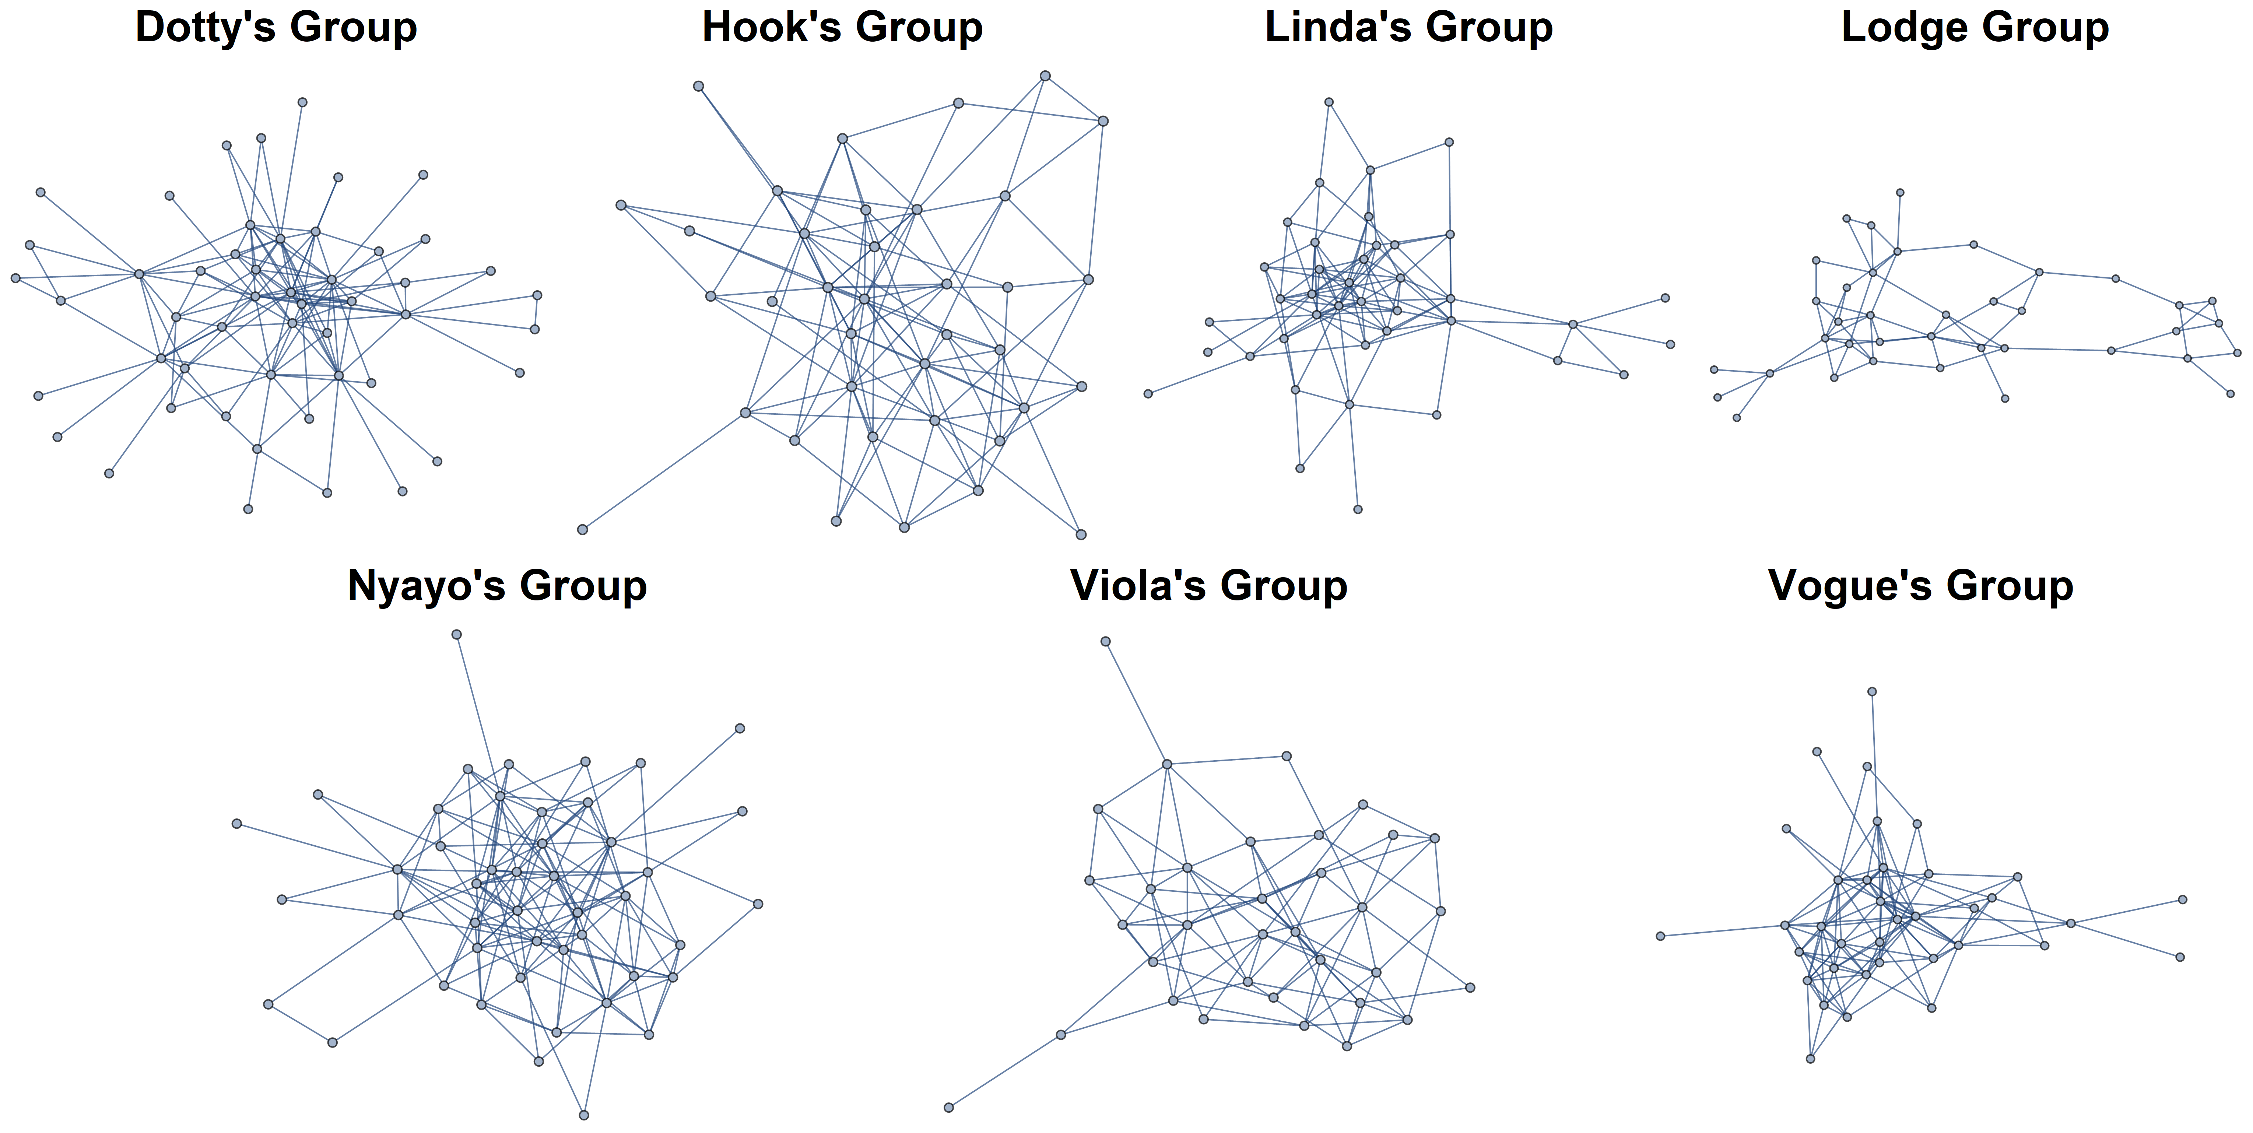
Figure 1. Observed, pre-fission social networks of baboon groups analyzed in this study. Clearly, splitting the social network while retaining social bonds is a complex undertaking.

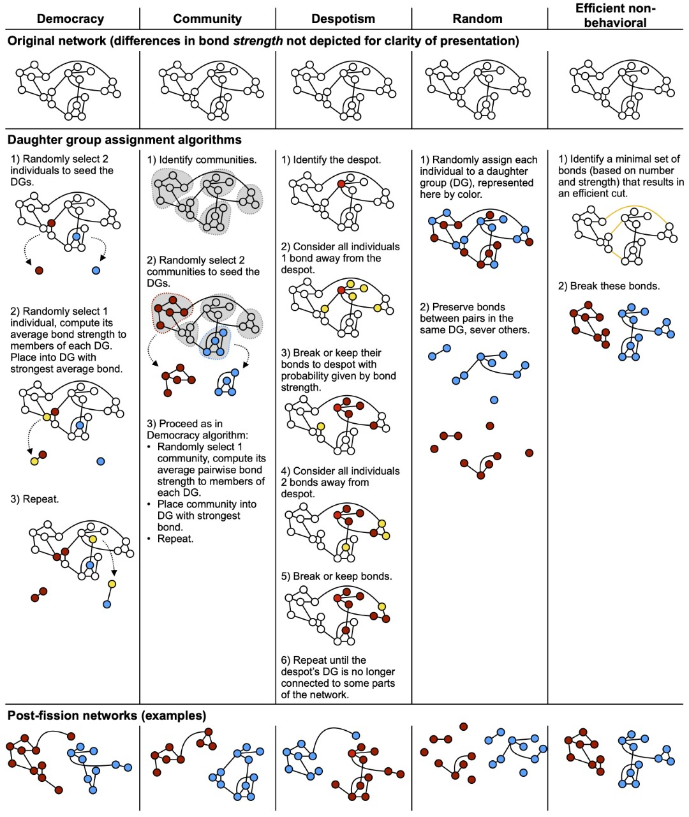
Figure 2. Visualization of the five fission algorithms on example networks. Each column represents one algorithm; the three rows represent the original network, the assignment processes for each algorithm, and examples outcomes, respectively. DG = daughter group.

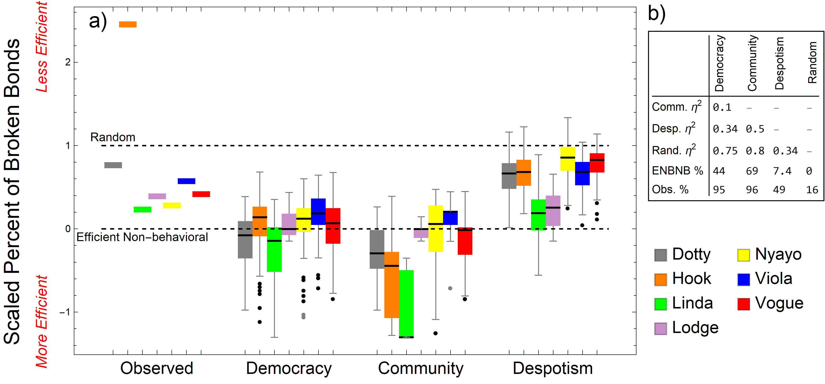

Figure 3. Percentage of bonds broken by the fission algorithms and during the observed fissions of the different baboon social groups. (a) The y-axis is scaled such that for each group a value of 0 represents the percentage of bonds broken by the efficient non-behavioral algorithm and a value of 1 represents the mean percentage of bonds broken by the random algorithm (dotted black lines). Boxes are clustered by algorithm; each color represents one of the seven different pre-fission social groups. For a given network, values below 0 denote breaking fewer bonds than the efficient non-behavioral algorithm and values above 1 denote breaking more bonds than random. The observed lines are the percentage of bonds that the observed fissions broke (see ‘How efficient were the observed baboon fissions’). In most of the actual fissions, the baboons broke more bonds than needed (observed lines fall above efficient non-behavioral) but fewer bonds than random (observed lines fall below random). Comparing other clusters of histograms to the dashed lines allows for an assessment of the efficiency of the fission algorithms (see ‘How efficient were each of the five fission algorithms’). The democracy and community algorithms break the lowest percentage of bonds, usually similar to the efficient non-behavioral network bisection. (b) The first three rows report η² for the pairwise comparisons between the stochastic algorithms. In general, η² of 0.01 is considered small, 0.07 medium, and 0.14 large⁵⁷. The last two rows show the average percentile of the stochastic algorithms that the efficient non-behavior algorithm and observed fissions fall on. For example, the value of 95 for observed fissions means that the baboons broke more bonds than 95% of fissions from the democracy algorithm. More extreme values (those closer to 0 and 100) indicate a lower probability that the efficient non-behavioral (ENBNB) or observed value would be produced by that stochastic algorithm.

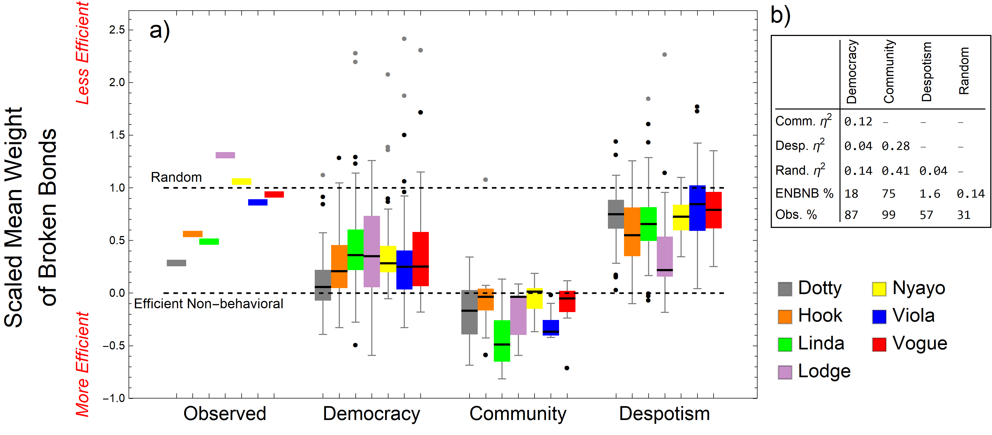

Figure 4. Average weight of broken bonds produced by the fission algorithms and during the observed fissions of the baboon social groups. The y-axis is scaled such that for each group a value of 0 is the average weight of broken bonds from the efficient non-behavioral algorithm and a value of 1 is the average weight of broken bonds from the random algorithm (dotted black lines). For a given = network, values below 0 denote breaking weaker bonds on average than the efficient non-behavioral algorithm and values above 1 denote breaking stronger bonds than random. The observed lines are the average weight of bonds that the observed fissions broke (see ‘How efficient were the observed baboon fissions’). Once again, the baboons disturbed their network more than was necessary (observed lines are above efficient non-behavioral) but typically less than random (observed lines below random). The community algorithm broke the weakest bonds on average, followed by democracy, then despotism (see ‘How efficient were the five fission algorithms’). b) Quantitative comparison of algorithms; see Figure 3b caption for details.

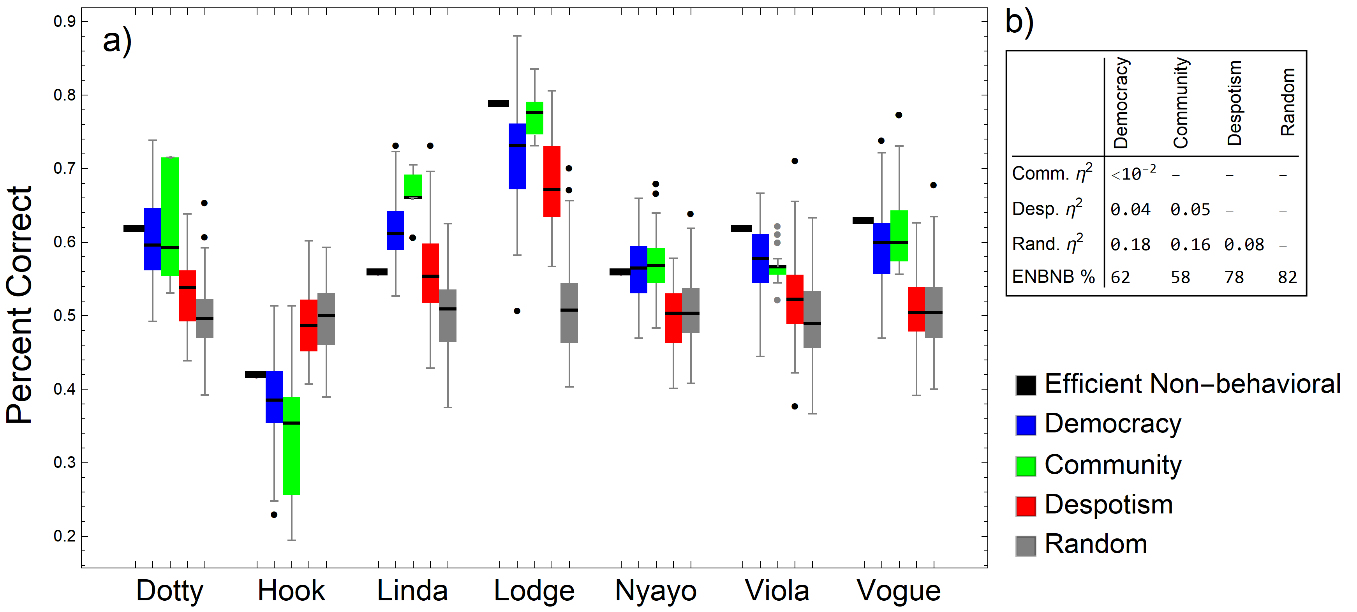

Figure 5. The democracy and/or community algorithm best predicted which bonds were broken or maintained in 6 of 7 of the observed fissions (all except for Hook’s). (a) Y-axis shows the percentage of bonds accurately assigned as broken versus maintained by each algorithm. Box plots are clustered by social group. (b) Quantitative comparison of algorithms; see Figure 3b caption for details.

