Supplementary materials
for
Thyroid hormone concentrations in female baboons: Metabolic consequences of living in a highly seasonal environment

Laurence R. Gesquiere, Christine Adjangba , Tim L. Wango, Vivian K. Oudu, Raphael S. Mututua, J. Kinyua Warutere, Long’ida Siodi, Fernando A. Campos, Elizabeth A. Archie, A. Catherine Markham*, Susan C. Alberts*

*These authors contributed equally

Table S1. Factors predicting fecal thyroid hormone concentrations across the hydrological year including estimates of genetic ancestry.
Fixed effects | AIC_{C} |  | ΔAIC_{C} |  | Akaike weights
ReproState ª + Season + Rain ^{b} + T_{av}² + Corms ^{c} + Resting ^{d} + Storage | -4828.00 | 0.00 |  | 0.14
ReproState + Season + Rain + T_{av}² + Corms + Resting + Storage + GpSize ^{e} | -4827.27 | 0.74 |  | 0.10
ReproState + Season + Rain + T_{av}² + Corms + Resting + Storage + HEF ^{f} | -4826.28 | 1.72 |  | 0.06
ReproState + Season + Rain + T_{av}² + Corms + Resting | -4826.23 | 1.77 |  | 0.06
ReproState + Season + Rain + T_{av}² + Corms + Resting + GpSize | -4826.21 | 1.79 |  | 0.06
ReproState + Season + Rain + T_{av}² + Corms + Resting + Storage + Ancestry ^{g} | -4826.13 | 1.87 |  | 0.05
ReproState + Season + Rain + T_{av}² + Corms + Resting + Storage + Feeding ^{h} | -4826.06 | 1.94 |  | 0.05
ReproState + Season + Rain + T_{av}² + Corms + Resting + GpSize + Storage + HEF | -4825.56 | 2.44 |  | 0.04
ReproState + Season + Rain + T_{av}² + Corms + Resting + GpSize + Storage + Ancestry | -4825.39 | 2.62 |  | 0.04
ReproState + Season + Rain + T_{av}² + Corms + Resting + GpSize + Storage + Feeding | -4825.37 | 2.64 |  | 0.04
ReproState + Season + Rain + T_{av}² + Corms + Resting + GpSize + HEF | -4824.57 | 3.43 |  | 0.02
ReproState + Season + Rain + T_{av}² + Corms + Resting + HEF | -4824.57 | 3.43 |  | 0.02
ReproState + Season + Rain + T_{av}² + Corms + Resting + Storage + HEF + Ancestry | -4824.41 | 3.59 |  | 0.02
ReproState + Season + Rain + T_{av}² + Corms + Resting + Ancestry | -4824.40 | 3.60 |  | 0.02
ReproState + Season + Rain + T_{av}² + Corms + Resting + GpSize + Ancestry | -4824.36 | 3.64 |  | 0.02
ReproState + Season + Rain + T_{av}² + Corms + Resting + Storage + HEF + Feeding | -4824.33 | 3.67 |  | 0.02
ReproState + Season + Rain + T_{av}² + Corms + Resting + GpSize + Feeding | -4824.31 | 3.69 |  | 0.02
ReproState + Season + Rain + T_{av}² + Corms + Resting + Feeding | -4824.28 | 3.72 |  | 0.02
ReproState + Season + Rain + T_{av}² + Corms + Resting + Storage + Ancestry + Feeding | -4824.19 | 3.81 |  | 0.02
ReproState + Season + Rain + T_{av}² + Corms + Resting + GpSize + Storage + HEF + Ancestry | -4823.68 | 4.32 |  | 0.02
ReproState + Season + Rain + T_{av}² + Corms + Resting + GpSize + Storage + HEF + Feeding | -4823.65 | 4.35 |  | 0.02
ReproState + Season + Rain + T_{av}² + Corms + Resting + GpSize + Storage + Ancestry + Feeding | -4823.48 | 4.52 |  | 0.01
ReproState + Season + Rain + T_{av}² + Corms + Resting + HEF + Ancestry | -4822.74 | 5.26 |  | 0.01
ReproState + Season + Rain + T_{av}² + Corms + Resting + GpSize + HEF + Ancestry | -4822.72 | 5.28 |  | 0.01
ReproState + Season + Rain + T_{av}² + Corms + Resting + GpSize + HEF + Feeding | -4822.66 | 5.34 |  | 0.01
ReproState + Season + Rain + T_{av}² + Corms + Resting + HEF + Feeding | -4822.61 | 5.39 |  | 0.01
ReproState + Season + Rain + T_{av}² + Corms + Resting + GpSize + Ancestry + Feeding | -4822.46 | 5.54 |  | 0.01
ReproState + Season + Rain + T_{av}² + Corms + Resting + Storage + HEF + Ancestry + Feeding | -4822.46 | 5.54 |  | 0.01
ReproState + Season + Rain + T_{av}² + Corms + Resting + Ancestry + Feeding | -4822.45 | 5.55 |  | 0.01
ReproState + Season + Rain + T_{av}² + Corms + Storage + Feeding | -4822.38 | 5.63 |  | 0.01
ReproState + Season + Rain + T_{av}² + Corms + GpSize + Storage + Feeding | -4821.79 | 6.22 |  | 0.01
ReproState + Season + Rain + T_{av}² + Corms + Resting + GpSize + Storage + HEF + Ancestry + Feeding | -4821.77 | 6.24 |  | 0.01
Fixed effects, Akaike information criteria (AIC_{C}), ΔAICc and Akaike weights (Burnham & Anderson, 1998) are provided for the first 32 candidate models with Akaike weights ≥ 0.01. ΔAICc was calculated as the difference between a given model and the best model. Akaike weights reflect the probability that a given model was the best model in the candidate model set. Models are sorted in order of their Akaike weights and those with a ΔAICc <2 are in bold.
ª ReproState= female reproductive state, ^{b} Rain= mean daily rainfall, ^{c} Corms= % corms eaten, ^{d} Resting=% time spent resting, ^{e} GpSize = group size, ^{f} HEF= % high-energy foods eaten, ^{g} Ancestry=estimate of genetic ancestry, ^{h} Feeding=% time spent feeding.

Table S2. Relative importance and model-averaged estimates for models across the hydrological year including estimates of genetic ancestry.
Fixed effects ª | Relative importance | Estimate ^{e} |  | Lower 95% ^{e} | Upper 95% ^{e} |  | Interpretation
(intercept) |  | 121.339 | 98.641 |  | 149.260
ReproState:  P vs. C ^{b} | 1.00 | -1.082 | -3.772 |  | 1.684 | ̶
PPA vs. C ^{b} |  | -8.681 | -10.900 |  | -6.407 | mT3 8.7% lower in lactating than in cycling females
Season:  LR vs. LD ^{c} | 1.00 | 1.634 | -3.292 |  | 6.812 | ̶
SD vs. LD ^{c} |  | -11.435 | -15.903 |  | -6.730 | mT3 11.4% lower in SR than in LD season
SR vs. LD ^{c} |  | -8.473 | -12.297 |  | -4.482 | mT3 8.5% lower in SR than in LD season
Daily rain | 1.00 | 3.789 | 2.823 |  | 4.763 | mT3 3.8% higher for each 1mm increase in daily rain
Temperature | 1.00
T_{av} |  | 171.331 | -11.682 |  | 733.589 | ̶
T_{av}² |  | -71.660 | -87.439 |  | -36.058 | mT3 lower when T_{av} is low or high
% corms eaten | 1.00 | -0.214 | -0.288 |  | -0.140 | mT3 2.1% lower for each 10 % increase in corms eaten
% time resting | 0.96 | 0.285 | 0.060 |  | 0.511 | mT3 2.9% higher for each 10 % increase in time resting
Storage | 0.67 | 1.147 | -0.923 |  | 3.260 | ̶
Group size | 0.44 | -0.037 | -0.153 |  | 0.078 | ̶
% HEF eaten ^{d} | 0.30 | -0.008 | -0.064 |  | 0.049 | ̶
% time feeding | 0.30 | -0.014 | -0.142 |  | 0.113 | ̶
Genetic ancestry | 0.28 | -1.244 | -12.597 |  | 11.584 | ̶
Fixed effects are sorted in order of their relative importance, using their sum of weights (SW). Variables above the dashed line have 95% CI that do not overlap 0 and are significant predictors of mT3 concentrations, while the parameters below the line have 95% CI that overlap 0 and do not significantly predict mT3 concentrations. Note that a variable may be listed above the line despite some of its categories having estimates with CI overlapping 0 (e.g. P vs. C).
ª For all categorical variables, the second category listed was the base level. ^{b} C = cycling; P = pregnant; PPA = post-partum amenorrhea. ^{c} LR = long rainy season; LD = long dry season; SD = short dry season; SR = short rainy season. ^{d} HEF = high-energy foods. ^{e} The Estimate and CI columns have been antilogged, subtracted by 1, and then multiplied by 100 to indicate the percent change in mT3 concentration associated with an increase of one unit of the predictor variable. The intercepts were antilogged only.

Table S3. Factors predicting fecal thyroid hormone concentrations within seasons between years.
Fixed effects | AIC_{C} |  |  | ΔAIC_{C} | Akaike weight
Short Rainy Season
ReproState + Rain ^{b} + T_{av} + Resting + Storage |  | -1921.37 |  | 0.00 | 0.09
ReproState + Rain + T_{av} + Resting |  | -1921.20 |  | 0.17 | 0.08
ReproState + Rain + T_{av} + Resting + Storage + Feeding |  | -1920.16 |  | 1.21 | 0.05
ReproState + Rain + T_{av} + Resting + Storage + GpSize |  | -1919.94 |  | 1.43 | 0.04
ReproState + Rain + T_{av} + Resting + GpSize |  | -1919.92 |  | 1.46 | 0.04
ReproState + Rain + T_{av} + Resting + Feeding |  | -1919.68 |  | 1.69 | 0.04
ReproState + Rain + T_{av} + Resting + Storage + Corms |  | -1919.67 |  | 1.70 | 0.04
ReproState + Rain + T_{av} + Resting + Storage + HEF |  | -1919.39 |  | 1.98 | 0.03
Short Dry Season
ReproState + HEF |  | -481.66 |  | 0.00 | 0.06
ReproState + HEF + T_{av} |  | -481.38 |  | 0.28 | 0.05
ReproState + HEF + GpSize |  | -479.90 |  | 1.77 | 0.02
ReproState + HEF + Resting |  | -479.85 |  | 1.81 | 0.02
ReproState + HEF + Feeding |  | -479.77 |  | 1.89 | 0.02
ReproState + HEF + Corms |  | -479.71 |  | 1.96 | 0.02
Long Rainy Season
ReproState + Rain + Resting + Corms + GpSize |  | -1476.58 |  | 0.00 | 0.10
ReproState + Rain + Resting + Corms |  | -1476.33 |  | 0.25 | 0.09
ReproState + Rain + Resting + Corms + GpSize + Storage |  | -1475.03 |  | 1.55 | 0.05
ReproState + Rain + Resting + Corms + GpSize + Feeding |  | -1475.01 |  | 1.58 | 0.05
ReproState + Rain + Resting + Corms + Feeding |  | -1474.76 |  | 1.82 | 0.04
ReproState + Rain + Resting + Corms + Storage |  | -1474.74 |  | 1.85 | 0.04
Long Dry Season
ReproState + Rain + Storage + Resting + HEF |  | -3718.53 |  | 0.00 | 0.06
ReproState + Rain + Storage + Resting + Corms |  | -3718.30 |  | 0.24 | 0.05
ReproState + Rain + Storage + Resting + HEF + Feeding |  | -3718.03 |  | 0.50 | 0.04
ReproState + Rain + Storage + HEF + Feeding |  | -3717.74 |  | 0.79 | 0.04
ReproState + Rain + Storage + Resting + Corms + Feeding |  | -3717.39 |  | 1.14 | 0.03
ReproState + Rain + Storage + HEF + Corms + Feeding |  | -3717.30 |  | 1.24 | 0.03
ReproState + Rain + Storage + Corms + Feeding |  | -3717.00 |  | 1.53 | 0.03
ReproState + Rain + Storage + Resting + HEF + GpSize |  | -3716.96 |  | 1.58 | 0.03
ReproState + Rain + Storage + Resting + Corms + GpSize |  | -3716.78 |  | 1.76 | 0.02
ReproState + Rain + Storage+ Resting + HEF + T_{av} |  | -3716.71 |  | 1.82 | 0.02
Fixed effects, AIC_{C}, ΔAICc and Akaike weights for models with ΔAICc <2 (see Table 2 for more details)

Table S4. Relative importance and model-averaged estimates for the parameters predicting mT3 concentrations within seasons between years.

Fixed effects | Relative importance | Estimate | Lower 95% | Upper 95% | Interpretation
Short rain
(intercept) |  | 39.446 | 10.227 | 152.137
Repro state: | 1.00
P vs. C ^{c} |  | -10.164 | -14.030 | -6.124 | mT3 10.2% lower in pregnant than in cycling females
PPA vs. C ^{c} |  | -9.362 | -12.825 | -5.762 | mT3 9.4% lower in lactating than in cycling females
Daily rain | 1.00 | 2.216 | 0.996 | 3.451 | mT3 2.2 % higher for each 1 mm increase in daily rain
% time resting | 0.91 | 0.421 | 0.022 | 0.822 | mT3 4.2% higher for each 10% increase in time resting
T_{av} | 0.82 | 4.201 | -1.439 | 10.163 | ̶
Storage | 0.57 | 1.619 | -1.771 | 5.127 | ̶
% time feeding | 0.40 | -0.087 | -0.421 | 0.248 | ̶
Group size | 0.35 | -0.029 | -0.152 | 0.095 | ̶
% corms eaten | 0.30 | -0.015 | -0.128 | 0.099 | ̶
% HEF ^{b} eaten | 0.27 | 0.000 | -0.085 | 0.084 | ̶
Short dry
(intercept) |  | 32.734 | 1.162 | 922.172
% HEF ^{b} eaten | 0.92 | 0.203 | 0.002 | 0.405 | mT3 2.0% higher for each 10% increase in HEF eaten
Repro state: | 0.85
P vs. C ^{c} |  | -0.283 | -7.597 | 7.610 | ̶
PPA vs. C ^{c} |  | -7.204 | -15.002 | 1.310 | ̶
T_{av} | 0.49 | 5.124 | -8.275 | 20.479 | ̶
% time resting | 0.36 | -0.068 | -0.381 | 0.247 | ̶
% time feeding | 0.34 | -0.050 | -0.305 | 0.207 | ̶
Group size | 0.30 | -0.021 | -0.160 | 0.118 | ̶
% corms eaten | 0.29 | 0.013 | -0.142 | 0.168 | ̶
Daily rain | 0.27 | -0.267 | -3.003 | 2.546 | ̶
Storage | 0.25 | 0.003 | -1.668 | 1.702 | ̶
Long rain
(intercept) |  | 121.619 | 74.096 | 199.622
Repro state: | 1.00
P vs. C ^{c} |  | -1.220 | -2.814 | 0.400 | ̶
PPA vs. C ^{c} |  | -9.560 | -13.347 | -5.608 | mT3 9.6% lower in lactating than in cycling females
Daily rain | 1.00 | 7.701 | 6.159 | 9.266 | mT3 7.7 % higher for each 1mm increase in daily rain
% time resting | 0.94 | 0.440 | 0.044 | 0.837 | mT3 4.4% higher for each 10% increase in time resting
% corms eaten | 0.80 | -0.171 | -0.410 | 0.068 | ̶
Group size | 0.52 | -0.073 | -0.253 | 0.107 | ̶
% HEF ^{b} eaten | 0.32 | 0.015 | -0.113 | 0.143 | ̶
% time feeding | 0.31 | 0.030 | -0.215 | 0.274 | ̶
Storage | 0.31 | 0.323 | -1.296 | 1.968 | ̶
T_{av} | 0.27 | -0.131 | -1.852 | 1.620 | ̶
Long dry
(intercept) |  | 107.895 | 78.601 | 148.106
Repro state: | 1.00
P vs. C ^{c} |  | -2.521 | -5.533 | 0.587 | ̶
PPA vs. C ^{c} |  | -9.758 | -12.455 | -6.977 | mT3 9.8% lower in lactating than in cycling females
Storage | 0.85 | 1.913 | -0.355 | 4.234 | ̶
Daily rain | 0.81 | 2.506 | -0.883 | 6.012 | ̶
% time resting | 0.73 | 0.302 | -0.199 | 0.804 | ̶
% HEF ^{b} eaten | 0.61 | 0.105 | -0.122 | 0.333 | ̶
% time feeding | 0.55 | -0.137 | -0.476 | 0.203 | ̶
% corms eaten | 0.52 | -0.058 | -0.220 | 0.103 | ̶
Group size | 0.33 | -0.021 | -0.126 | 0.084 | ̶
T_{av} | 0.29 | -0.038 | -0.643 | 0.570 | ̶
Fixed effects are sorted in order of their relative importance, using their sum of weights. Parameters above the dashed line have 95% CI that do not overlap 0 and are significant predictors of mT3 concentrations, while the parameters below the line have 95% CI that overlap 0 and do not significantly predict mT3 concentrations. Abbreviations as in Table 3.
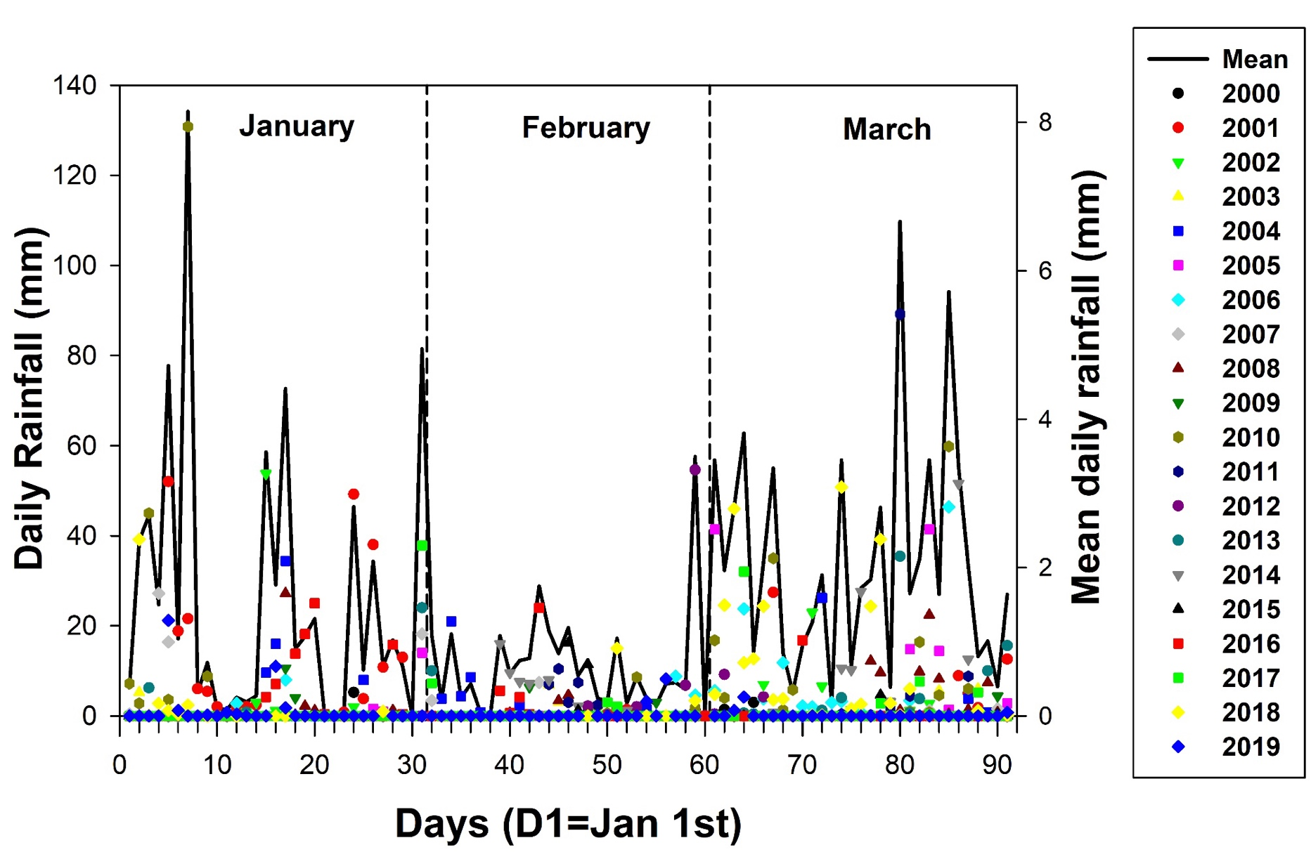
Fig. S1. Daily rainfall in Amboseli from January through March for hydrological years 2000-2019. Each colored point represents daily rainfall (left y-axis) on a given day and year between 2000 and 2019. Mean daily rainfall (right y-axis), across hydrological years 2000-2019 is represented as a black line.

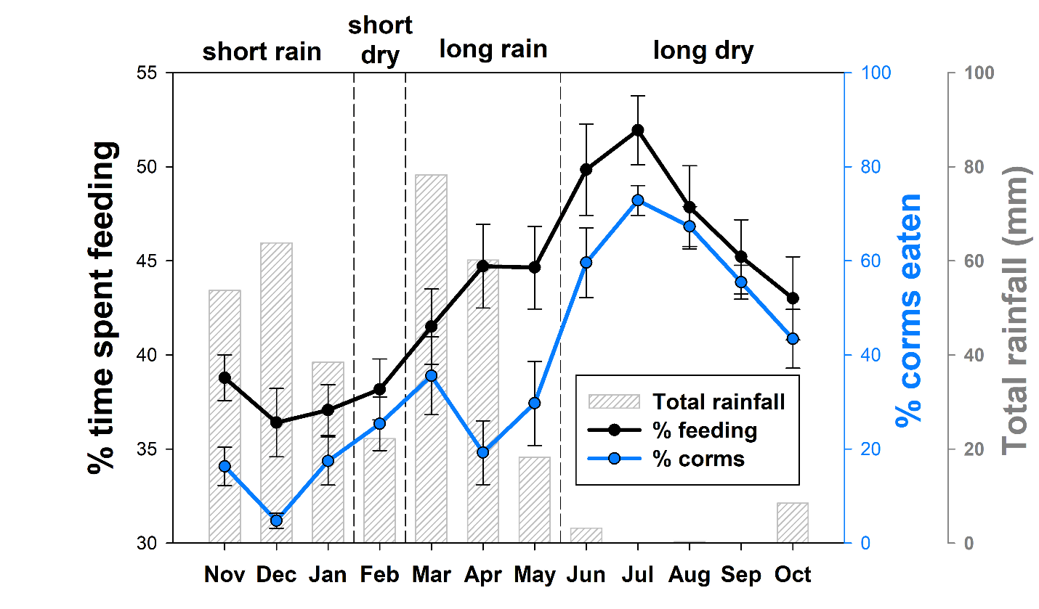

Fig. S2. Monthly and seasonal patterns of the percent of time spent feeding and the percent of corms eaten (see Table 1 for definitions). Each monthly value represents the mean (±SE) across the 14 years of this study (2005–2018).

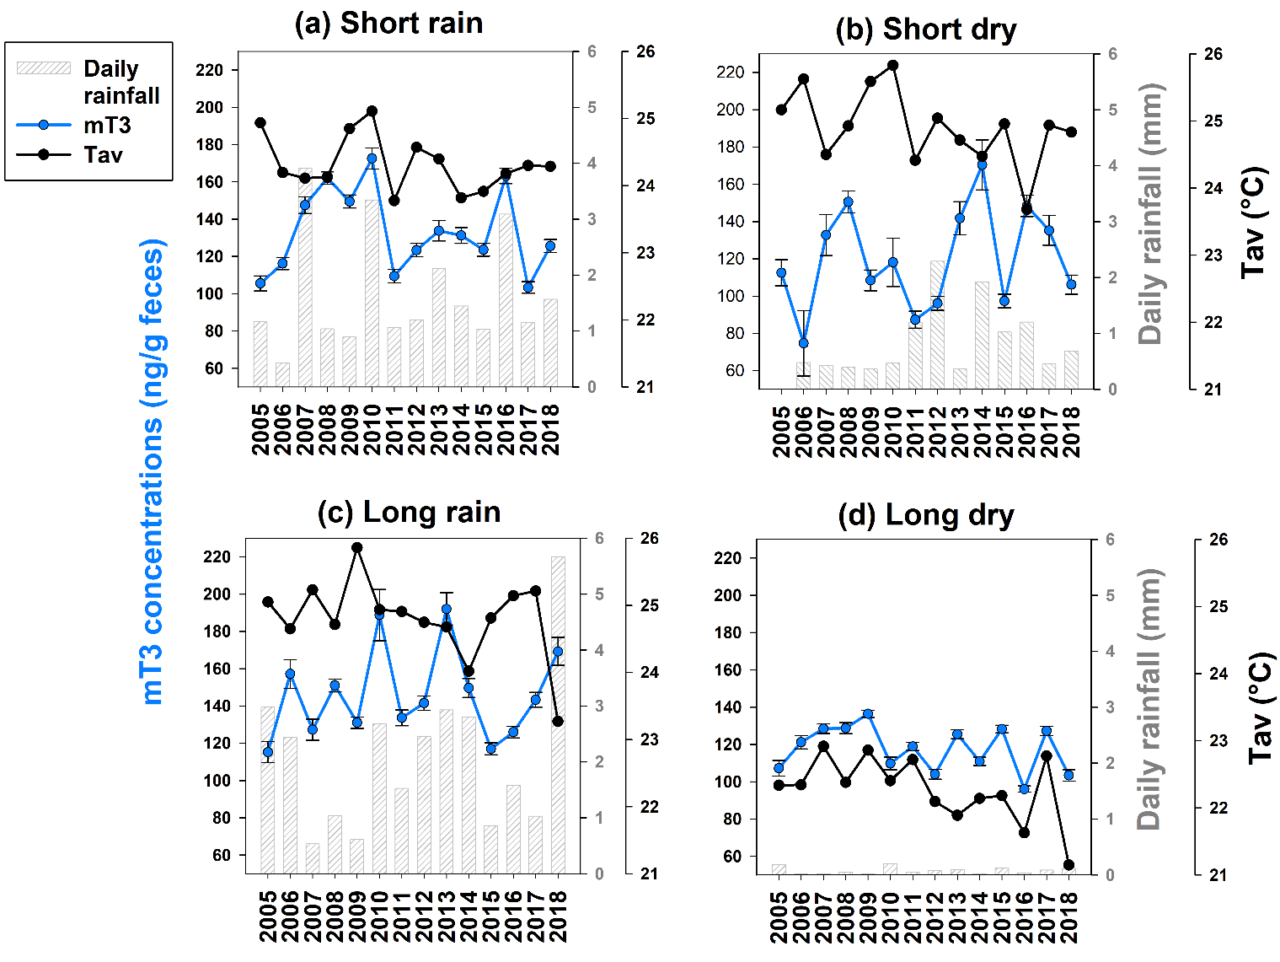

Fig. S3. Year to year variation in daily rainfall, average temperature (T_{av}) and fecal thyroid hormone (mT3) concentrations for (a) short rainy season, (b) short dry season, (c) long rainy season, and (d) long dry season. Each bar represents the mean daily rainfall for a given season for each hydrological year. Each black dot represents the mean daily T_{av} across days of a given season for each hydrological year. Each blue dot represents the mean and SE of mT3 concentrations across all female fecal samples for a given season and hydrological year.

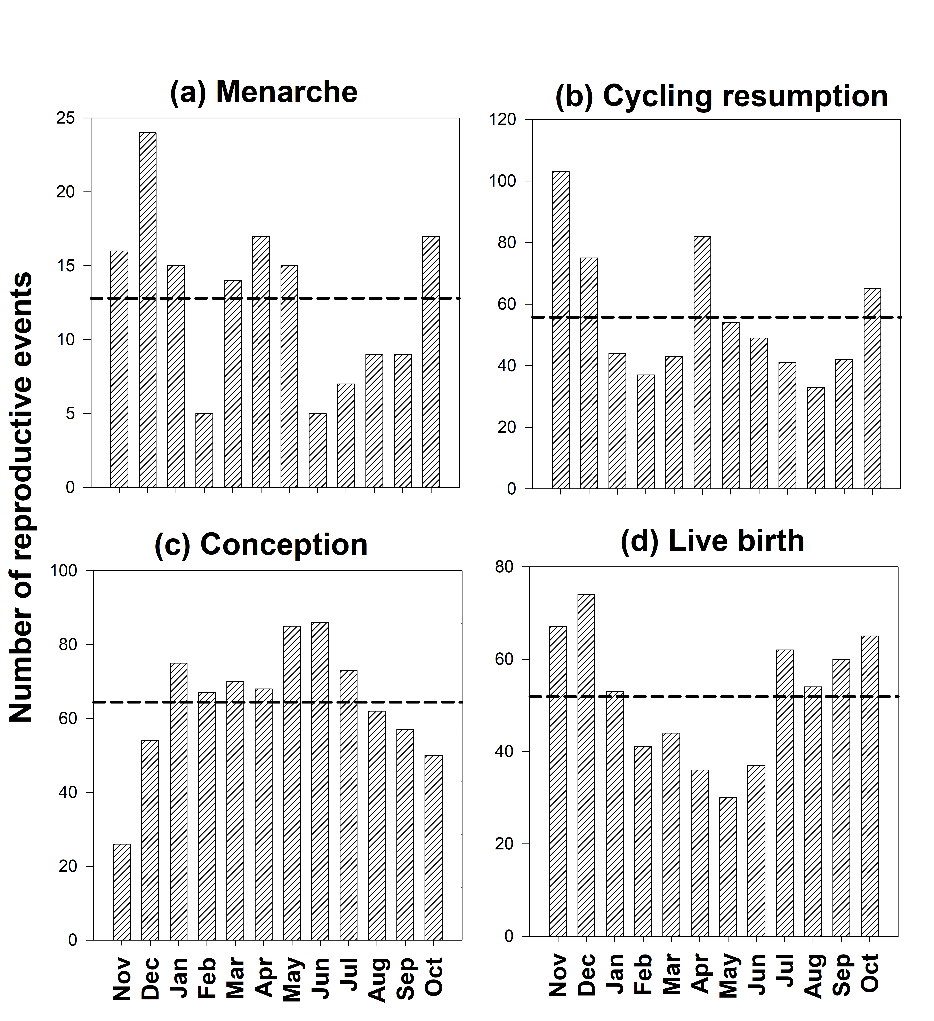
Fig. S4. Frequency distribution by month of (a) menarche, (b) cycling resumption, (c) conception, and (d) live birth in Amboseli baboons from 2005-2018. Months are ordered according to “hydrological year”, as noted in Fig. 1. The dotted line on each graph represents the mean expected even frequency of reproductive events (i.e., in the absence of seasonal pattern of reproductive events).

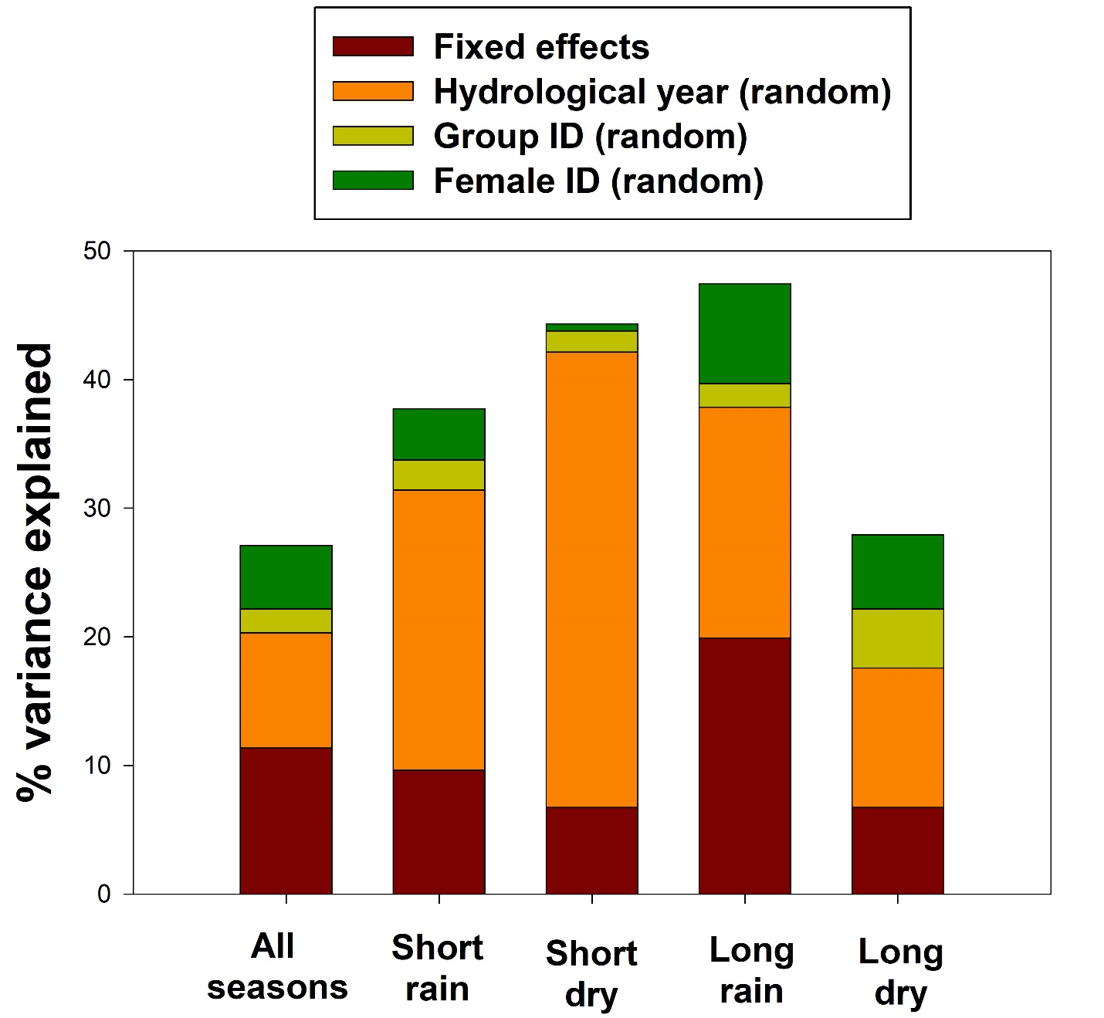

Fig. S5. Percent of variance explained by the fixed effects and random effects, for the full model and for each of the 4 seasons.

