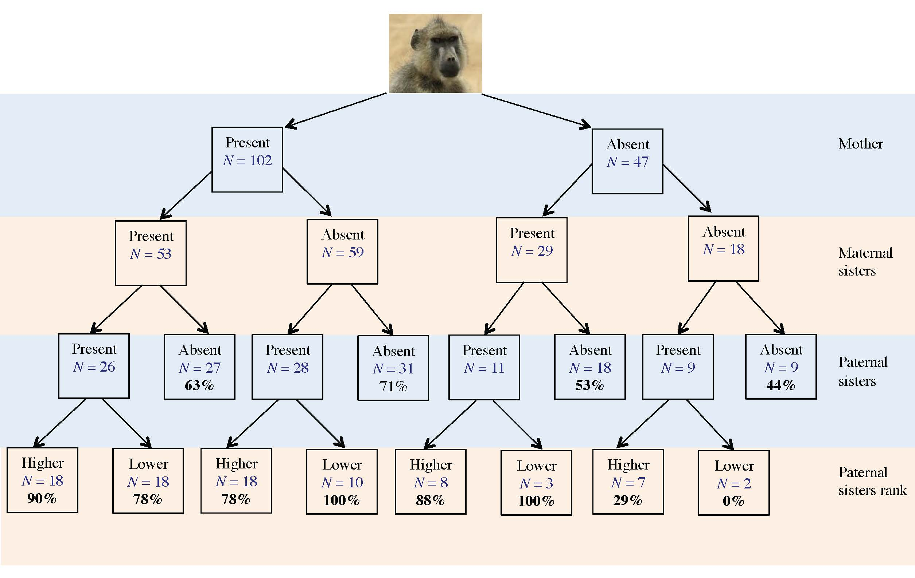

Figure S1. Influence of female kin on whether a female savannah baboon ranked with her matriline at menarche. The number of females co-residing with their mother, maternal sisters and paternal sisters (of higher or lower rank) are presented for individuals in the paternal kin data set. The percentage of females in each category that ranked with their respective matrilines at menarche is given in bold. Although sample sizes were small, these percentages were higher for individuals with paternal sisters across categories (except when mothers and maternal sisters were absent).
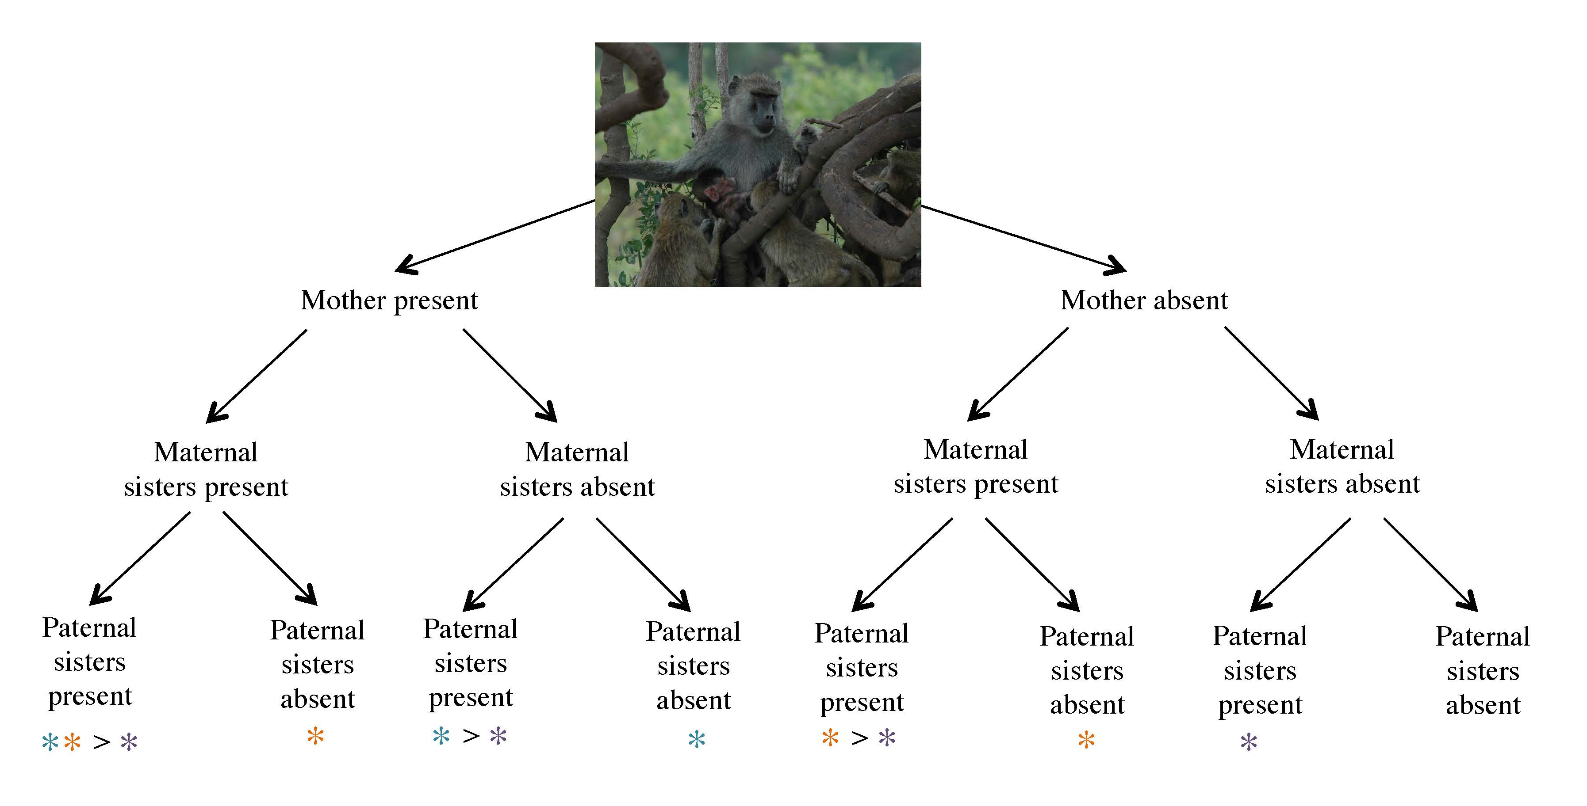

Figure S2. Patterns of support provided to female relatives in savannah baboons. Males may co-reside with many possible combinations of maternal and paternal female relatives (depicted here) and should, in theory, partition their support accordingly. Predicted support preferences are indicated by coloured asterisks (* support mother; * support maternal sister; * support paternal sister). We assume that males will support both maternal and paternal kin, but will prefer maternal kin because the certainty of relatedness is higher. Additionally, maternal age and the size of the matriline may be important.
Table S1
Influence of maternal relatives on whether a female savannah baboon achieved a rank adjacent to her matriline (at menarche) using various measures of brother presence

 | Fixed effects | K | Brother  proportion 1  AIC_{c} | Brother proportion 2  AIC_{c} | Brother presence
At menarche | Mother + Sisters + Group size | 3 | 272.45
N = 194 | Mother + Group size | 2 | 274.95
 | Mother + Sisters + Brothers + Group size | 4 | 275.82 | 277.41 | 276.67
 | Mother + Brothers + Group size | 3 | 278.22 | 278.86 | 278.38
 | Group size | 1 | 278.65
 | Sisters + Group size | 2 | 279.74
 | Mother | 1 | 280.71
 | Mother + Sisters | 2 | 281.90
 | Intercept only | 0 | 282.87
 | Sisters + Brothers + Group size | 3 | 283.03 | 284.47 | 283.81
 | Mother + Brothers | 2 | 284.70 | 284.65 | 284.71
 | Sisters | 1 | 285.44
 | Mother + Sisters + Brothers | 3 | 285.92 | 286.33 | 286.32
 | Brothers | 1 | 286.89 | 287.31 | 287.32
 | Sisters + Brothers | 2 | 289.46 | 290.19 | 290.18
This table includes the fixed effects, number of variables included (K), and Akaike’s Information Criterion (AIC_{c},) for each candidate model as provided in the main text (Table 3). Here, we include the AIC_{c} value for each model’s fit using three definitions of ‘Brothers’ (i.e. mature maternal brother presence). Specifically, we fitted models using the following variables: (1) proportion of days that the brother spent in co-residency with the focal female, but only over the year preceding menarche (brother proportion 1); (2) proportion of days that the brother spent in co-residency with the focal female, from birth to menarche (brother proportion 2); and (3) a binary variable noting whether the focal female had any mature maternal brothers at menarche. In all cases, these three measures of brother presence yielded similar results.

Table S2
Influence of maternal relatives on youngest ascendancy within matrilines (at menarche) in savannah baboons using various measures of brother presence

 | Fixed effects | K | Brother  proportion 1  AIC_{c} | Brother proportion 2  AIC_{c} | Brother presence
At menarche | Mother + Sisters | 2 | 77.67
N = 85 | Mother | 1 | 78.00
 | Mother + Sisters + Brothers | 3 | 79.53 | 79.96 | 79.45
 | Mother + Brothers | 2 | 80.01 | 79.64 | 79.96
 | Sisters | 1 | 105.24
 | Sisters + Brothers | 2 | 106.99 | 106.80 | 107.02
 | Intercept only | 0 | 109.75
 | Brothers | 1 | 111.77 | 110.91 | 111.28
Columns as in Table S2. Again, our results here suggest that the effect of brother presence on female rank outcomes was robust to various definitions of brother presence.

