Supporting Information 1
Distribution of sleeping sites coded for the number of nights they were used and permanent waterholes relative to the ranges of 5 baboon social groups observed from 1 Apr 2008–31 Aug 2010.
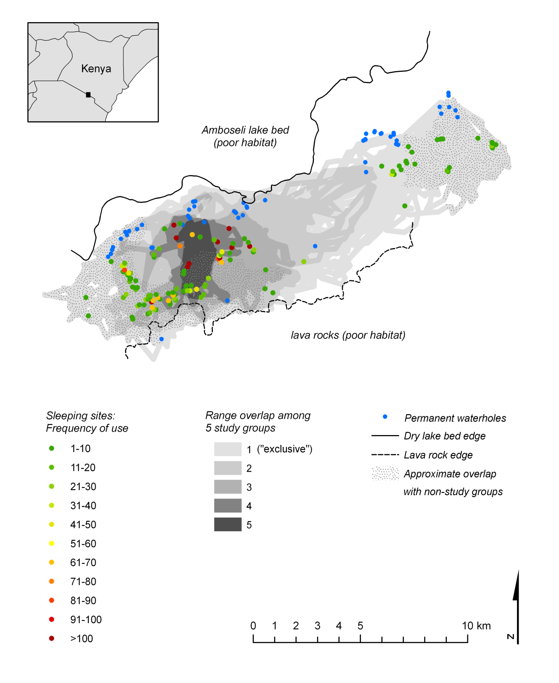
Supporting Information 2
Distribution of sleeping sites used by 5 baboon social groups observed from 1 Apr 2008–31 Aug 2010 coded for the number of trees they contained.
